SUSTAINABLE OUTREACH AND UNIVERSAL LEADERSHIP LIMITED
(SOUL)



KIMS HOSPITAL - INVOICE TRACKING SYSTEM
Version 0.9

REQUIREMENT DOCUMENT

VERSION HISTORY

Date | Version No. | Created By | Updated Section | Updated By
27-10-2022 | Version 0.1 | Priytesh Shah
31-10-2022 | Version 0.2 |  | Sectio 2, point 4  Section 3, 5, 6 | Sharmistha Panda
01-11-2022 | Version 0.3 |  | Changed types of Invoice & Workflow diagram | Priytesh Shah
04-11-2022 | Version 0.4 |  | Added Section 1, Section 2, Section 3 diagram, Section 4 - point 4, Added Section 5, Updated, Added Section 9 - Email, Section 10 - point 2 | Sharmistha Panda
08-11-2022 | Version 0.5 |  | Master Screen details  Updated the note sections of each of the workflow diagram  Section 6.1 | Sharmistha Panda
10-11-2022 | Version 0.5 |  | Patient Refund - Net Refund Calculation | Sharmistha Panda
15-11-2022  16-11-2022 | Version 0.6 |  | Section 1.5, Section 2, Section 4, Section 5,  Section - 12, return to third party  Section - 13, payment workflow  Section - 14, patient refund  Section 17.1, 17.2, Section 21 | Sharmistha Panda
25-11-2022 | Version 0.8 |  | Section -4 (points 13, 14)  Section 16 - Authorized Signature Table added  Section - 17 (Print PDF) , iii added  Section 19 (Email) -Section 19.1,19.2 - added points,Section 19.4 Added | Sharmistha Panda
28-11-2022 | Version 0.9 |  | All Sections | Sharmistha Panda
22-12-2022 | Version 10 |  |  | Sharmistha Panda

TABLE OF CONTENTS

1. Master Data / Screens 6
1.1 Company 6
1.2 Department 7
1.3 Employee 8
1.4 Supplier Group 10
1.5 Supplier 10
1.6 Bank Details 12
1.7 Reason of Refund 12
1.8 Insurance Form 12
2. User Roles and Permissions 13
2.1 Role Permission 13
2.2 User Creation 13
2.3 User Permission 13
3. Types of Invoices 14
4. High Level Workflow (Invoices) 14
5. Note Sheet - Important Pointers 16
6. Note Sheet UI Fields 17
7. Invoice Form 18
7.1 Submission of Invoice Form 18
7.2 Cancellation of Invoice form 21
8. Note Sheet - Consumable Workflow: (PO T-Kitchen) 22
8.1 UI 22
8.1.1 Submission / Approval of Note Sheet by Note Keeper 22
8.1.2 Cancellation of note sheet by Note Sheet Keeper 25
8.2 Authorized Signature Table 26
8.2.1 Journal Entry By Accounts Clerk 27
8.2.2 Passed for Payment 28
8.3 Fields of T-Kitchen Screen : 30
8.4 Workflow Diagram 31
9. Workflow of Note Sheet Keeper for all Invoice Types 33
10. Consignment Workflow: 33
10.1 UI 33
10.2 Authorized Signature Table 34
10.3 Fields of Consignment Screen : 36
10.4 Workflow Diagram 38
11. PO Material Management Workflow: 40
11.1 UI 40
11.2 Authorized Signature Table 41
11.3 Fields of Material Management Screen : 42
11.4 Workflow Diagram 45
12. Non PO Contract Workflow: 46
12.1 UI 46
12.2 Authorized Signature Table 47
12.3 Fields of Non PO contract Screen : 47
12.4 Workflow Diagram 50
13. Non PO Non-contract Workflow: 51
13.1 UI 51
13.2 Authorized Signature Table 52
13.3 Fields of Non PO Non Contract Screen : 53
13.4 Workflow Diagram 56
14. Pharmacy Workflow: 57
14.1 UI 57
14.2 Authorized Signature Table 58
14.3 Fields of Pharmacy Screen : 59
14.4 Work flow Diagram 61
15. Patient Refund Workflow: 62
15.1 UI 62
15.2 Authorized Signature Table 65
Accounts Clerk 66
15.3 Fields of Patient Refund Screen : 66
15.4 Net Refundable Calculation 67
15.5 Work Flow diagram 69
16. Return and Transfer to Third Party 70
17. Batch Payment Workflow 72
18. Authorized Signature Table 76
19. Print Format / PDF 78
20. Documents For Attachment 78
21. Email 80
21.1 Vendor / Supplier 80
21.2 Note Sheet Creator / Other Users 80
21.3 Third Party Department 81
21.4 Email Attachment 81
21.5 Email for Amount Clearance Period in Days 81
22. Dashboard 82
23. System Settings 83
23.1 Financial Criteria 83
24. Dynamic User Workflow 83
25. Role Permission Tool 85
26. User Permission Tool 86
27. Absent Employee Replacement Tool 87
28. Report 87

Master Data / Screens

1.1 Company
- Screen shall look like (as shown below)
- Screen shall have the following fields :
- Company - Data field
- Abbr - Data field
- Company Address - Data field

- User / Employee of the system shall belong to one or multiple companies
- The company information shall be fetched in the note sheet form

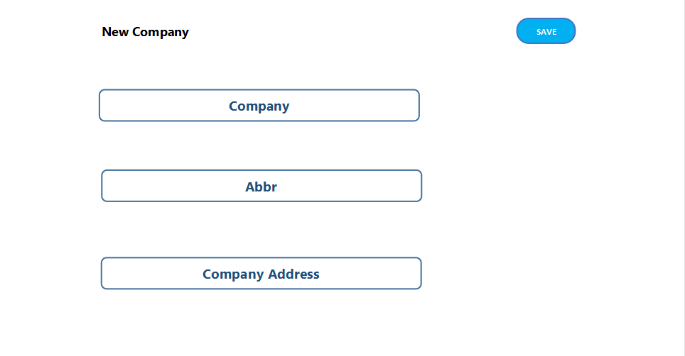

1.2 Department
- Department shall be the list of departments in KIMS hospital such as

- IT Department
- Maintenance Department
- Bio Medical Engineer Department
- Material Management Department
- Accounts Department

- Department UI shall look like as shown below

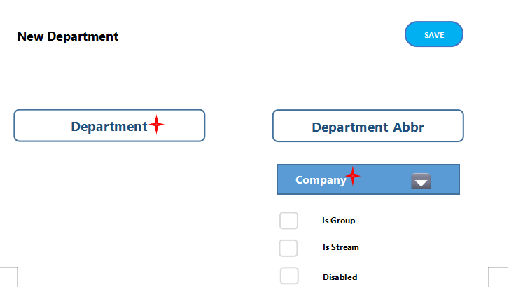
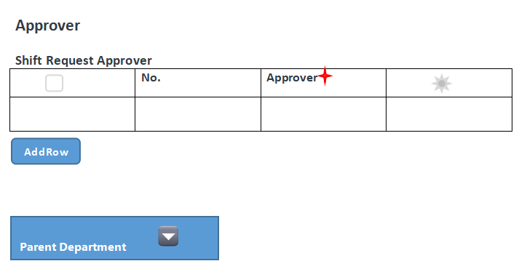

- User / Employee of a company shall belong to a particular department. For e.g. an user with designation as accounts clerk shall belong to Accounts Department
- In Department screen, Company shall be fetched from Company master screen. Company details should exist prior
- In the note sheet form, department shall be fetched and shown in the screen

1.3 Employee
- User of the system shall be the Employee
- Employee UI should look like as shown below

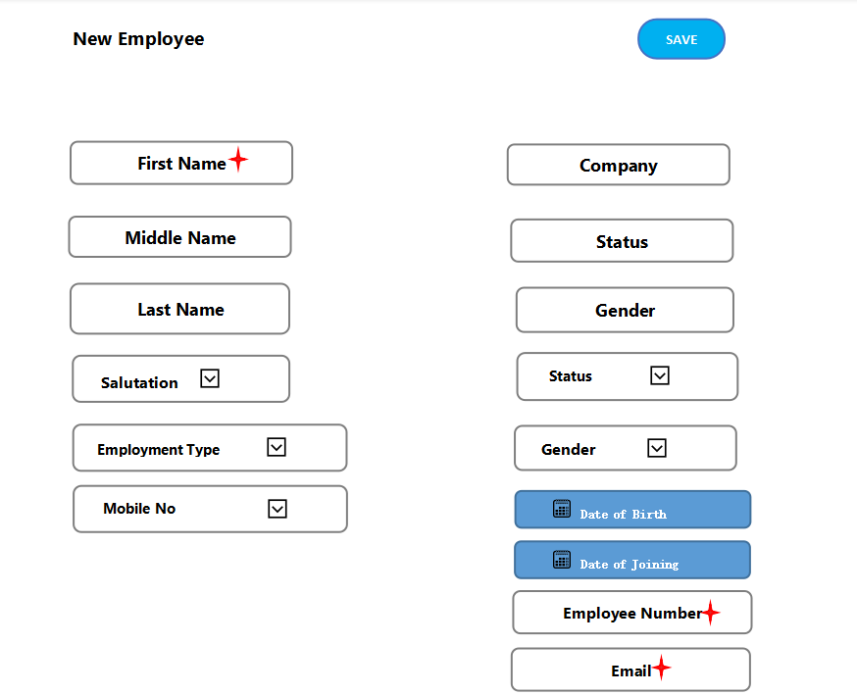
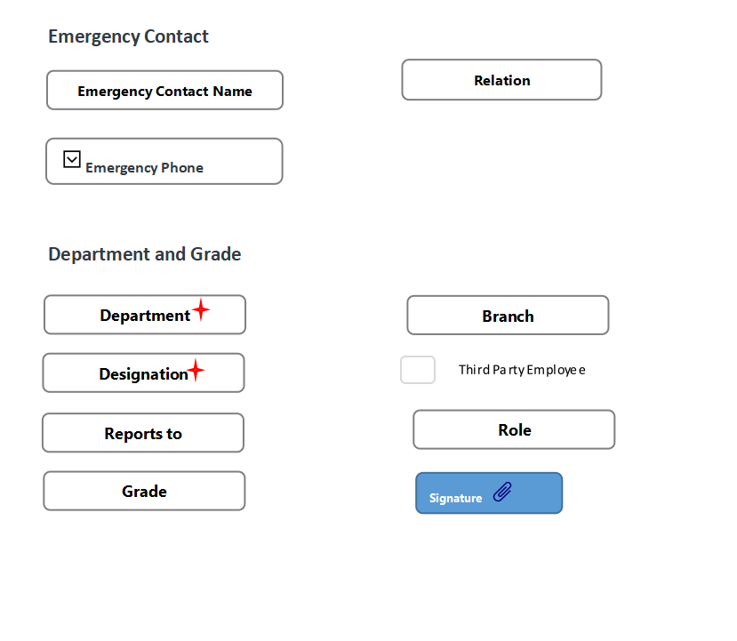

- Company shall be fetched from Company master screen
- Department shall be fetched from Department master screen
- On creation of an employee, user shall also be automatically created
- All the user levels maintained in the invoice workflow, shall be maintained in the Employee screen. For e.g. note creator, Dy Head, MM, Pro VC, shall be the employees in the system

1.4 Supplier Group
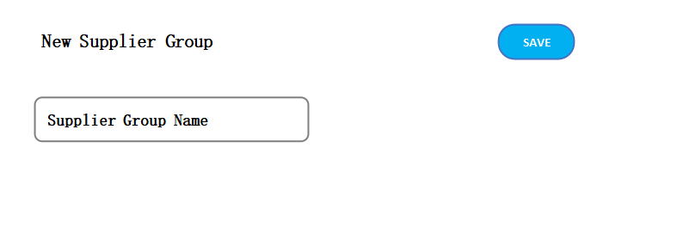

1.5 Supplier
- Supplier shall be the vendor details such as supplier code , supplier name, supplier type, company, supplier address as shown below
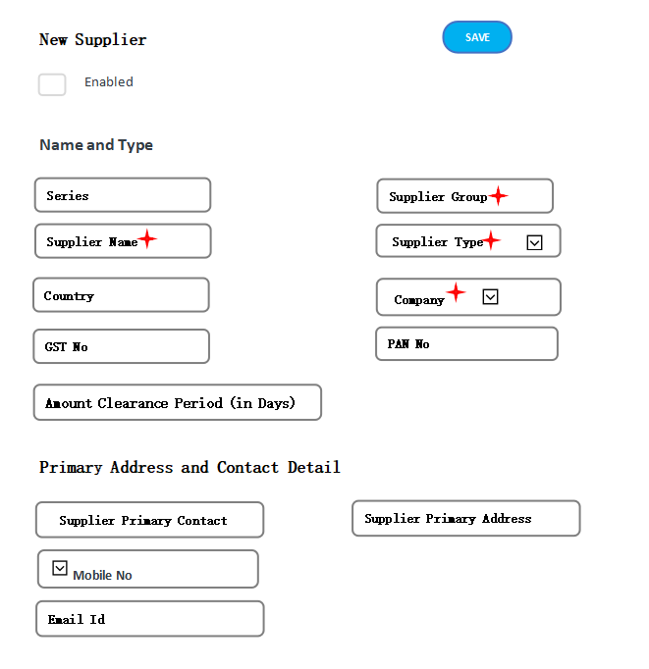
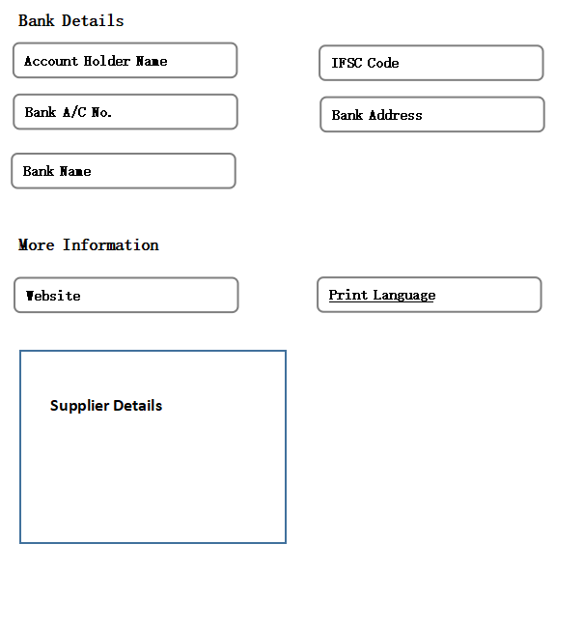
- Company shall be fetched from Company master screen
- Supplier Group shall be fetched from Supplier Group master screen
- The supplier code and name shall be fetched in Invoice form and note sheet screen

- Payment term shall be maintained in Supplier screen. This term shall be fetched in Note Sheet screen as “Amount Clearance Period” field

1.6 Bank Details
This shall have the bank information required to process the payment. For e.g. Bank Name, Bank A/C No. , Branch details, etc

1.7 Reason of Refund
- Reason of Refund shall be part of Patient Refund screen

- For any health schemes, if the checkbox “Insurance mandatory Check” shall be selected then the Insurance section in Patient Refund screen will become mandatory
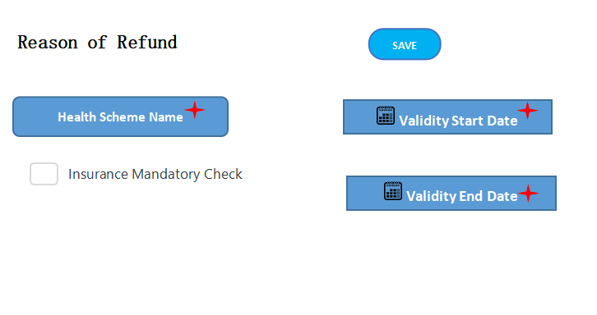
Figure : Reason of Refund UI

1.8 Insurance Form

- The Insurance form shall retain information about Insurance companies.

- The Insurance details shall be captured in Patient Refund screen

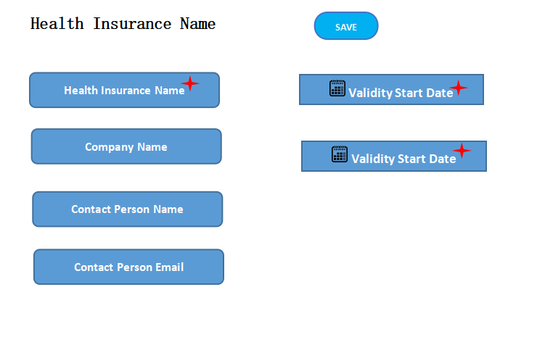
Figure : Insurance Form UI

User Roles and Permissions

2.1 Role Permission

- User shall be granted the access to Read / Edit / View / Delete screens by System Administrator
- The access shall be granted based on the role / designation of the user / employee
- The UI and functionality has been explained in Section 25

2.2 User Creation

Each user of the system shall be created as Employee. Employee shall be a master screen maintaining all details as specified in section 1.3

2.3 User Permission
- Logged in user shall be able to see his / her department information only.
- Only System Administrator shall be allowed to grant the permission to user to his / her department (Section 26)
- The UI should look like (as shown below)

Types of Invoices
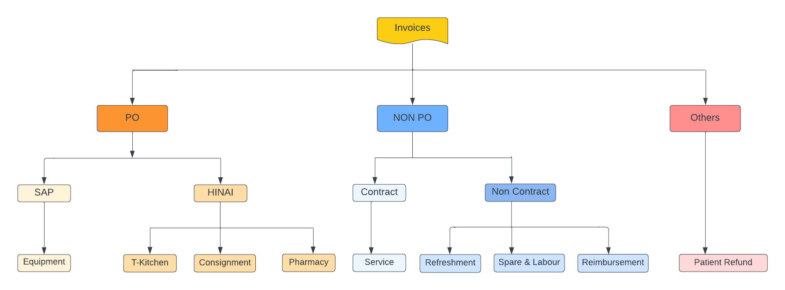

Invoices will be divided into three sections:

- PO Based
- Non PO based
- Others

Each of the Invoices will be group into either one of the above

High Level Workflow (Invoices)
Pre - requisite data -
Some of the data shall be fetched from SAP or HINAI system post integration
Supplier / Vendor shall hand over the Invoice to the Department / Note Sheet Keeper of the Department

- The note sheet creator shall receive the Invoice from the Vendor
- The note sheet creator shall fill in the Invoice form and Submit
- The note creator shall fill in information to the note sheet

- Note sheet creator shall attach mandatory documents such as
PO based invoice types :
- Invoice
- PO

Non PO based invoice types :
- Invoice

- Note sheet creator shall save the note sheet . The note sheet status shall initially be Draft

- After saving this note sheet in draft state, the Authorized Signature child table containing the signature shall be appended by the user’s signature and details who has created this Note-sheet (i.e. note creator)

- Note sheet creator shall verify and save the note sheet. The note sheet status shall be in verify and save

- After saving this note sheet in Verify and Save state, the Authorized Signature child table containing the signature shall be appended by note creator’s signature

- After Verify and Save, the note sheet creator shall submit the note sheet. The note sheet status shall be in verified and submitted by note keeper

- After submitting this note sheet, the “Authorized Signature” child table containing the signature shall be appended by note sheet creator’s signature

- System shall allow the note sheet creator to Cancel the note sheet prior submitting the note sheet. In that case, note sheet status shall be Cancelled

- The record created in “Authorized Signature” child table shall be updated on cancellation

- Based on the invoice type, the workflow shall be triggered post verified and submitted by note keeper

- PO T-Kitchen - Section 8
- PO Consignment - Section 9
- PO Material Management - Section 10
- Non PO Contract - Section 11
- Non PO Non Contract - Section 12
- Pharmacy - Section 13
- Patient Refund - Section 14
- Return and Transfer to Third Party - Section 15

- In the Invoice workflow, system shall allow the user to either

- Approved and proceed to next user level or
- Return and Transfer to note sheet creator / any of the predecessor

- At any given point of time, user shall also have the option to “Return and Transfer to third party department” [Section 16]

- For Invoice work flow, email shall be triggered to the vendor, users as suggested in Section 21

- For Invoice workflow, note sheet shall end at “Passed for Payment” status by Accounts Clerk

- Payment workflow shall be triggered for all the batch of invoices whose status will be Passed for Payment [Section 15]

- Post verification and payment processing, vendor and department shall be notified via email for successful payment as suggested in Section 14

- Email shall have Invoice attachment Section 14

- At each level of successful user approval, message or alert shall pop-up in the screen

Note Sheet - Important Pointers
- Department shall be based on the note creator / logged in user
- Supplier address and name to be fetched and shown in the screen
- In the note sheet form, Complete form shall be read only in “Passed for Payment” status
- Priority field in note sheet screen shall decide the urgency of the note sheet
- Each invoice types shall have list of supporting documents to be attached. Attachment shall have a checkbox. On selection, the particular document attachment shall be mandatory

- File attachment (document attachment) browse option shall only be “My Device”

- Note Sheet status shall be “Draft” unless it is submitted. After submission of the note sheet, the workflow (approval or Return and Transfer or Return to 3rd party) shall trigger

- “Note Creator” shall have the authority to Approve and Reject (or Cancel) the note sheet

- Other users shall have the authority to Approve and Return and Transfer along with Reject comments. They shall not have the authority to cancel the note sheet

- At any given point of time, user shall also have the option to “Return and Transfer to third party department” (mentioned in Section 14)

- For each level of approval or return workflow, print view of the note sheet along with documents attached shall be visible to the user on click of Download button

- The approval of note sheet at user level shall be based on “financial criteria” (Section 23.1)

- Calculation of Net Final Amount to be Paid (In Rs.) for

- PO Consumable, Material Management, Non PO Contract, Non PO Non Contract should be

- Net Final Amount to be Paid (In Rs.) = Total Amount (In Rs.) - [TDS Amount To Be Deducted (In Rs.) + Advance Amount Already Paid (In Rs.) ]

- For PO Consignment

- Net Final Amount to be Paid (In Rs.)” = Field “Total Amount (In Rs.) - field “Less Credit Note Amount”

- In case of Patient Refund, the field “Approval of TPA / Insurance / Corporate / OSTF” shall be enabled if the refund comes under Insurance

Note Sheet UI Fields
The note sheet creator will enter the following fields in UI

- Company - Drop down
- Note Sheet No. - System generated number
- Date of Note Sheet - Date field
- Name of School/Department - Drop down
- Item of Purchase/Expense - Drop down
- Supplier Code - Drop down
- Supplier Name - Auto fetch based on supplier code
- Details of Invoices as per service type - this shall have PO Number
- from SAP or HINAI
- Total Amount (IN Rs.) - Currency
- TDS amount to be deducted - Currency
- Advance amount paid. - Currency
- Net Final amount - Currency
- Submit as Draft.
- Token Number to be generated for tracking of Invoice
- Email to be triggered to Vendor / Supplier

Invoice Form
The note sheet keeper shall receive the Invoice from the Vendor. The invoice form UI shall be as shown below

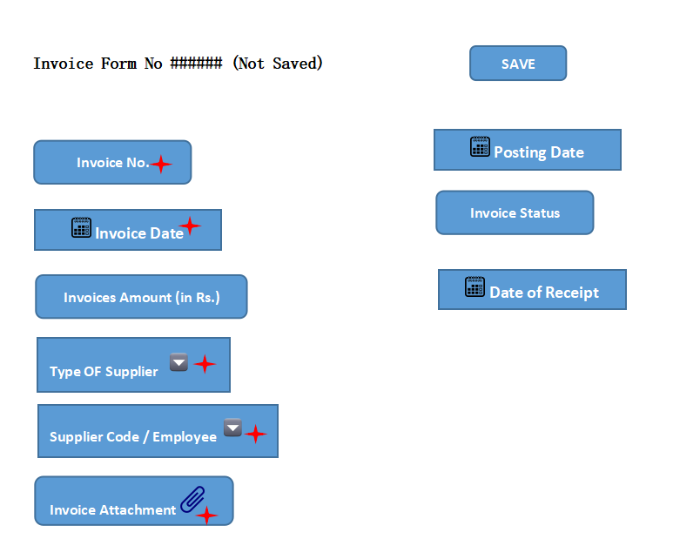

7.1 Submission of Invoice Form

- The Note Sheet Keeper shall enter the data and click SAVE button (as shown above)

- On SAVE, the the field Invoice Status shall be changed to “Draft”
- The note sheet keeper shall click SUBMIT button

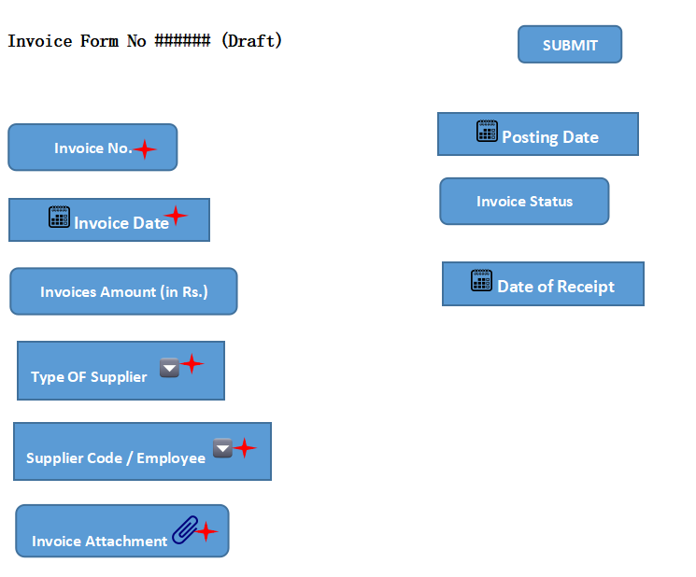

- On SUBMIT, the the field Invoice Status shall be changed to “Passed For Note Sheet”

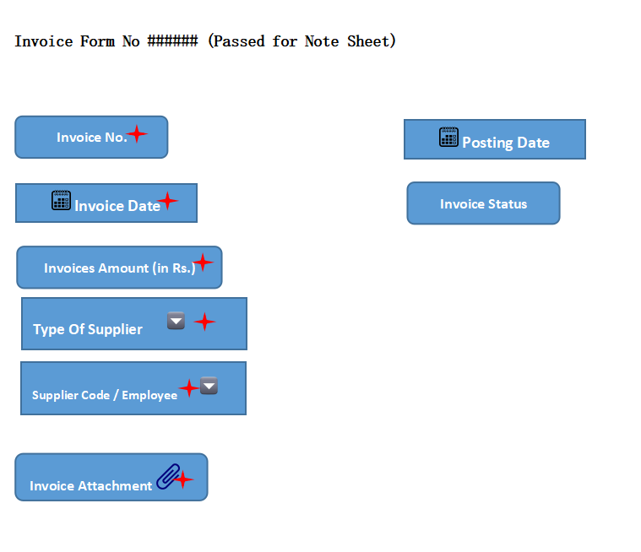

- Post submission of Invoice Form, the note sheet keeper shall navigate to Note Sheet form
- Note Sheet Keeper shall enter data and SAVE the form .
- On SAVING the note sheet form,

- the Invoice form status shall be changed to “Note Sheet Prepared”
- three additional fields shall be present in Invoice Form (as shown below)

- Note Sheet Status
- Note Sheet No.
- Type of Note Sheet

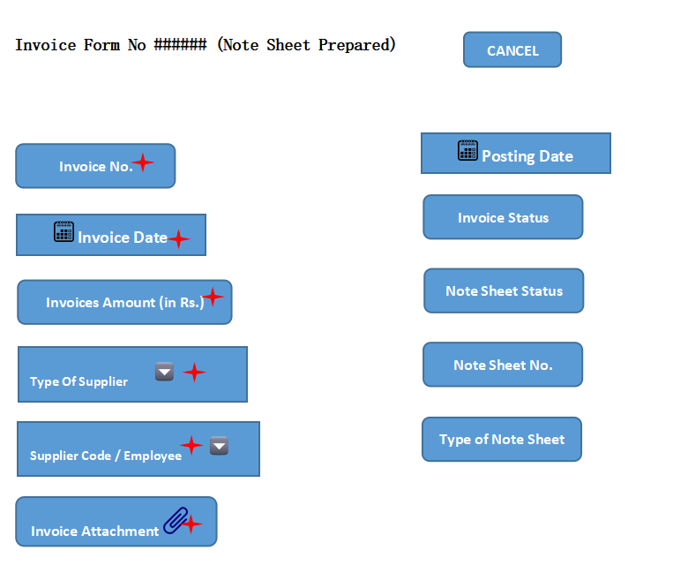

- The Note Sheet Status field shall keep changing based on the workflow state of Invoice. For e.g.

Note Sheet Status Field Value | Note Sheet Workflow State
Draft | Note sheet status is Draft
Verify and Save | Note sheet status is Verify and Save
Submitted by Note Sheet Keeper | Note sheet is submitted by note sheet keeper
Approved By …….. | Approval by user role….
Passed for Payment | Passed for payment by Accounts Clerk

- The Invoice Form UI for Batch Payment Process

Assumption
Note Sheet status “Passed for Payment”
The Batch payment process is initiated

When the batch payment process form will be in DRAFT status, the Invoice Form shall have two additional fields :

- Batch Payment No.
- Payment Status

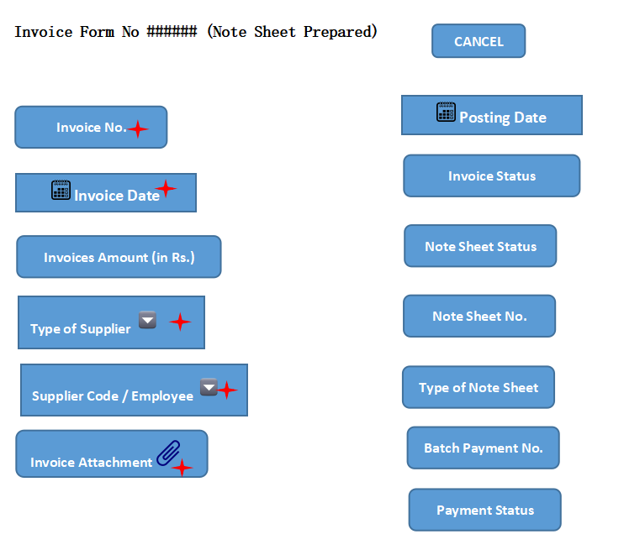

- The email shall be triggered to Supplier / Vendor on Submission of Invoice form by note sheet keeper (i.e. click of SUBMIT button in Invoice Form)

7.2 Cancellation of Invoice form

- The Note sheet keeper can cancel the Invoice after saving the form but before submitting
- On click of CANCEL button, the field Invoice Status shall be changed to “Cancelled”

Note Sheet - Consumable Workflow: (PO T-Kitchen)

8.1 UI

8.1.1 Submission / Approval of Note Sheet by Note Keeper
- Asst Store Keeper (Note Keeper) shall login to see the below screen
- The following screen shall be visible after log in

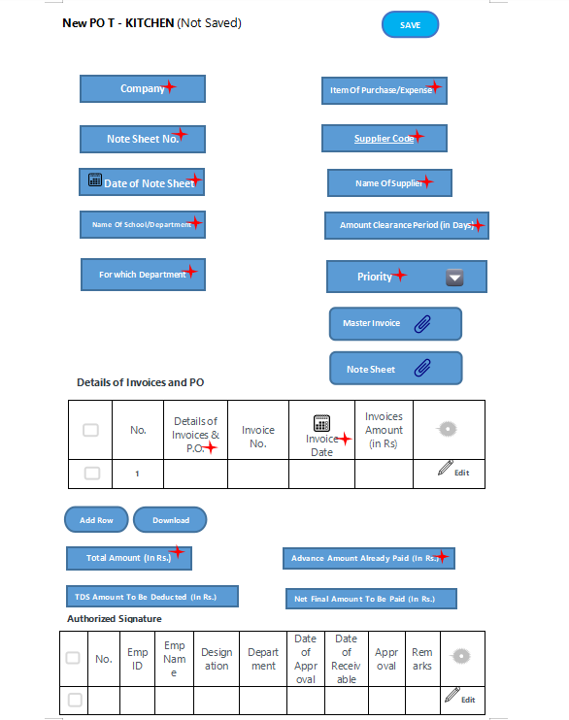

- Asst Store Keeper (Note Keeper) shall enter information and click Save button. The note sheet status shall initially be Draft

- System shall send an email notification to Vendor along with the Note sheet no.

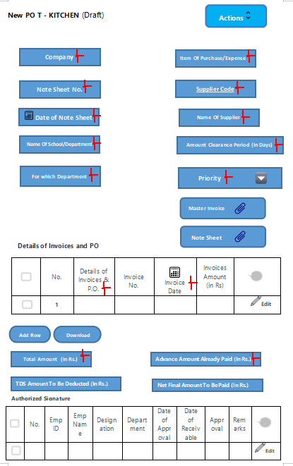

- After saving this note sheet in draft state, the Authorized Signature child table containing the signature shall be appended by the user’s signature and details who has created this Note-sheet (i.e. note creator)

- Asst Store Keeper (Note Keeper) shall click Actions button

- On click of Actions button, two options shall be available to Note Sheet Keeper:

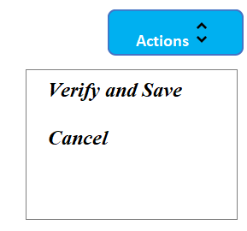

- Asst Store Keeper (Note Keeper) shall click Verify and Save button. The note sheet status shall be in Verify and Save

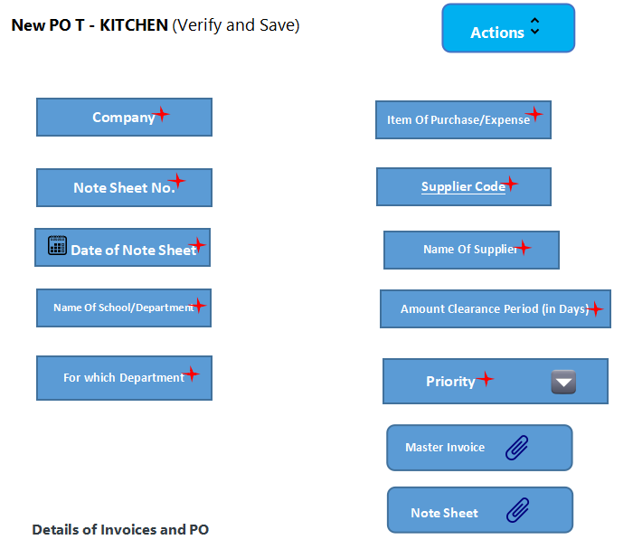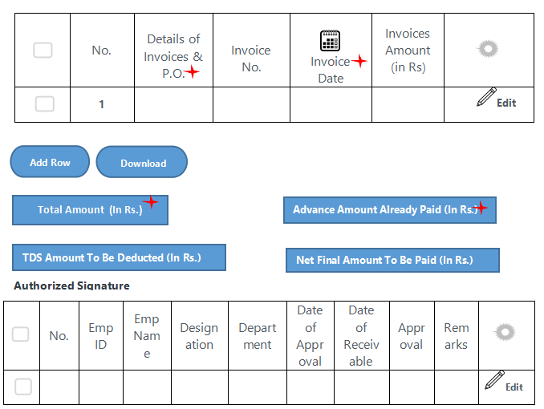

- After saving this note sheet in Verify and Save state, the Authorized Signature child table containing the signature shall be appended by note creator’s signature

- Asst Store Keeper (Note Keeper) shall click on Actions button
- On click of the button, system shall show Submit button as shown below :

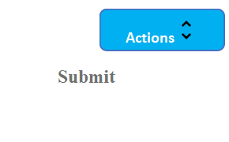

- Asst Store Keeper (Note Keeper) shall click Submit button. The note sheet status shall be in Verified and Submitted by Note Creator

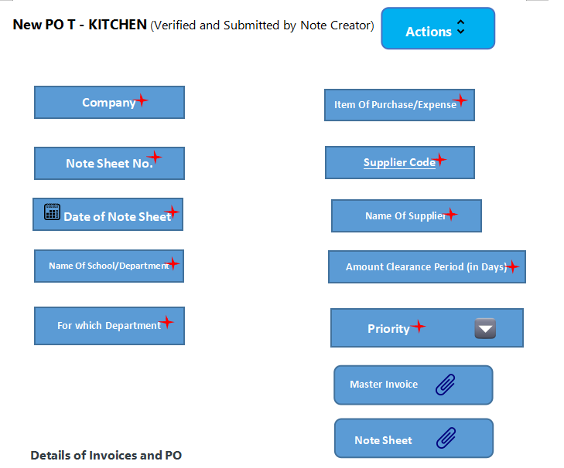

- After submitting this note sheet, the “Authorized Signature” child table containing the signature shall be appended by note sheet creator’s signature

8.1.2 Cancellation of note sheet by Note Sheet Keeper

- System shall allow the note sheet creator to Cancel the note sheet prior submitting the note sheet i.e. post “Verify and Save” status

- Asst Store Keeper (Note Keeper) shall click Cancel button.

- The record created in “Authorized Signature” child table shall be updated on cancellation

8.2 Authorized Signature Table
- A row shall be appended to the below table each time a user verifies and approves the note sheet to the next user level

- First user shall be Note Sheet Keeper

- An existing row for a particular user action shall be updated each time a user rejects and transfers the note sheet (columns such as Transfer To, Remarks, Disapproval name)

Sl No | User Role | Click Action | Form Status | Next User Level
1 | Asst. Store keeper | Save | Draft | Asst. Store keeper
2 | Asst. Store keeper | Verify and Save | Verify and Save | Asst. Store keeper
3 | Asst. Store keeper | Cancel | Cancelled | Asst. Store keeper
4 | Asst. Store keeper | Submit | Verified and Submitted by Note Sheet Creator | Dy. Head , MM
5 | Dy. Head , MM | Approve | Verified and Recommended by Dy. Head , MM | GM, MM
6 | Dy. Head , MM | Return and Transfer | Verified and Submitted by Note Sheet Creator | Asst. Store keeper
7 | GM, MM | Approve | Verified and Approved by GM, MM | Accounts Clerk
8 | GM, MM | Return and Transfer | Status of the returned user level | Any of the predecessor
9 | Accounts Clerk | Approve | Verified and Approved by Accounts Clerk | CFO, KIMS
10 | Accounts Clerk | Return and Transfer | Status of the returned user level | Any of the predecessor
11 | CFO, KIMS | Approve | Verified and Approved by CFO | Director Administration
12 | CFO, KIMS | Return and Transfer | Status of the returned user level | Any of the predecessor
13 | Director Administration | Approve | Verified and Approved by Director Administration | Audit User 1
14 | Director Administration | Return and Transfer | Status of the returned user level | Any of the predecessor
15 | Audit User 1 | Approve | Bill Received by Audit User1 | Audit User 2
16 | Audit User 1 | Return and Transfer | Status of the returned user level | Any of the predecessor
17 | Pro-VC | Approve | Approved by Pro- VC | Accounts Clerk
18 | Pro-VC | Return and Transfer | Status of the returned user level | Any of the predecessor
19 | Audit User 2 | Approve | Approved by Audit User 2 | Pro-VC
20 | Audit User 2 | Return and Transfer | Status of the returned user level | Any of the predecessor
21 | Accounts Clerk | Approve | Journal Entry by Accounts Clerk | Accounts Clerk
22 | Accounts Clerk | Approve | Passed for Payment

8.2.1 Journal Entry By Accounts Clerk
- Journal entry by Accounts Clerk shall be common step for PO T-Kitchen, PO Consignment, PO Material Management, PO Pharmacy

- The section shall be available only after approval by Audit User2

- On login by Accounts Clerk, the section shall be available for entry
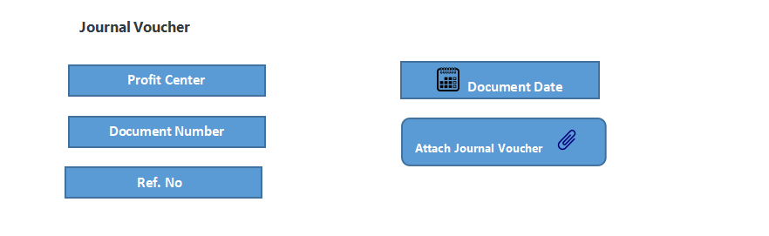

8.2.2 Passed for Payment
On Passed for Payment status, the screen should look like as shown below

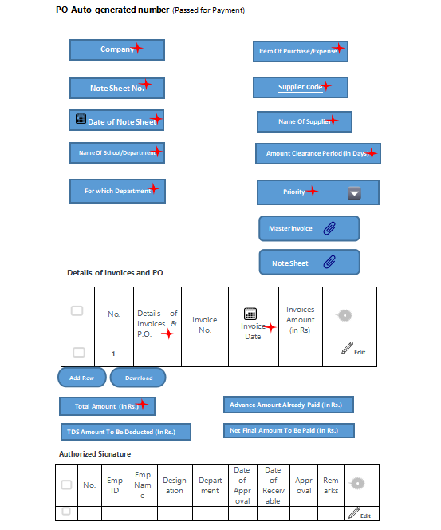
Header Fields
FIELD NAME | FIELD TYPE | Action / Validation
Company | Link Field | Fetched from Company master screen. If logged in user is associated with more than one company then, the field shall give the option to choose ELSE associated company name shall be displayed
Note Sheet No. | Data Field | User entry , alphanumeric
Date Of Note Sheet | Date | User entry of date
Name Of School/Department | Link Field | Shall be fetched from the Department for user selection
For which Department | Link Field | To be fetched from Department master screenfor user selection
Item Of Purchase/Expense | Data Field | User entry , alphanumeric
Supplier Code | Link Field | Fetched from Supplier master screen
Name Of Supplier | Data Field | Auto fetch based on supplier code, read only
Amount Clearance Period (in Days) | Int | Numeric value
Priority | Drop Down  Urgent  High Priority  Normal  Low Priority | User selection
Master Invoice Attachment | Attachment | Only pdf file
Note sheet Attachment | Attachment | Only pdf file

8.3 Fields of T-Kitchen Screen :

Details of Invoices & PO (Child Table)
Details of Invoices & P.O. | Data Field
Sl.No. | Auto Fill | Auto fill , read only
Invoice No. | Data Field | User entry, alphanumeric
Invoice Date | Date | User entry or selection of date
Invoices Amount(in Rs) | Currency Field | Only currency
Requisition form or Indent | Attachment | Only pdf file
Vendor Quotation | Attachment | Only pdf file
Comparative Statement | Attachment | Only pdf file
Approval Sheet | Attachment | Only pdf file
PO | Attachment | Only pdf file
Delivery Challan | Attachment | Only pdf file
Invoice | Attachment | Only pdf file
GRN | Attachment | Only pdf file
Bill Summary | Attachment | Only pdf file
Credit Memo | Attachment | Only pdf file
Purchase Receive Note (PRN) | Attachment | Only pdf file
Others | Attachment | Only pdf file

Authorized Signature Table
Sl NO. | Auto Fill | Auto Fill
Emp ID | Link Field | Auto Fill
Emp Name | Data Field | Auto Fill
Designation | Data Field | Auto Fill
Date of Approval | Date | Auto Fill
Date of Receivable | Date | Auto Fill
Department | Link Field | Auto Fill
Remarks | Data Field | Auto Fill
Approval Status | Data Field | Auto Fill
Transfer to | Data Field | Auto Fill
Disapproval Check | Data Field | Auto Fill
Disapproval Emp | Data Field | Auto Fill
Disapproval Emp Name | Data Field | Auto Fill
Single user | Data Field | Auto Fill

8.4 Workflow Diagram

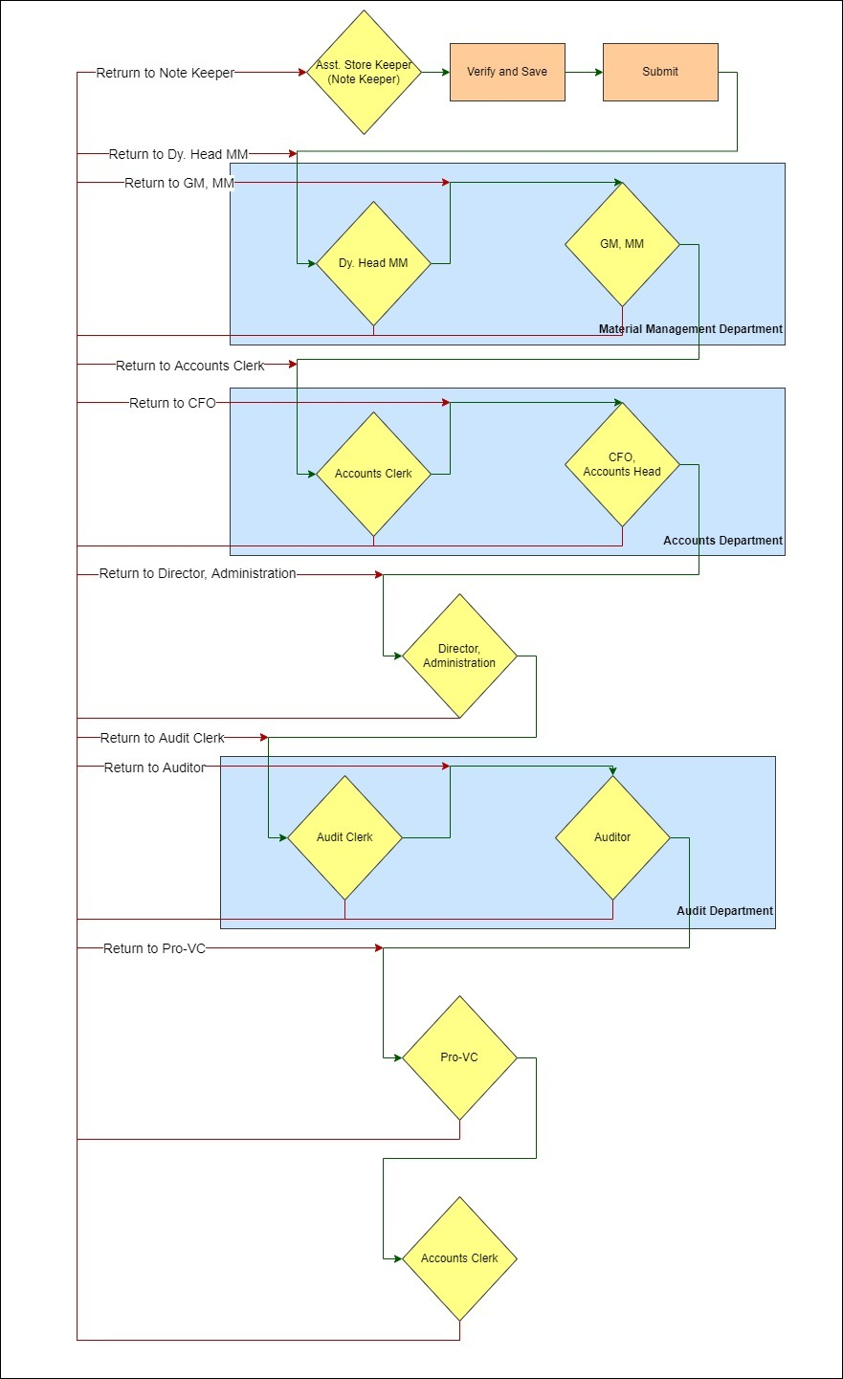

Workflow of Note Sheet Keeper for all Invoice Types

- Steps a - m of Section 8.1.1 Submission / Approval of Note Sheet by Note Keeper and steps 1 -3 of Section 8.1.2 shall be same for all the invoice types i.e.

- PO T-Kitchen
- PO Consignment
- PO Material Management
- Non PO Contract
- Non PO Non Contract
- Pharmacy
- Patient Refund

Consignment Workflow:

UI
The process of Store Consignment (Note Sheet Keeper) submission , approval and cancellation of note sheet shall be same as steps (a) to (m) of Section 8.1.1 and (a) to (c) of Section 8.1.2

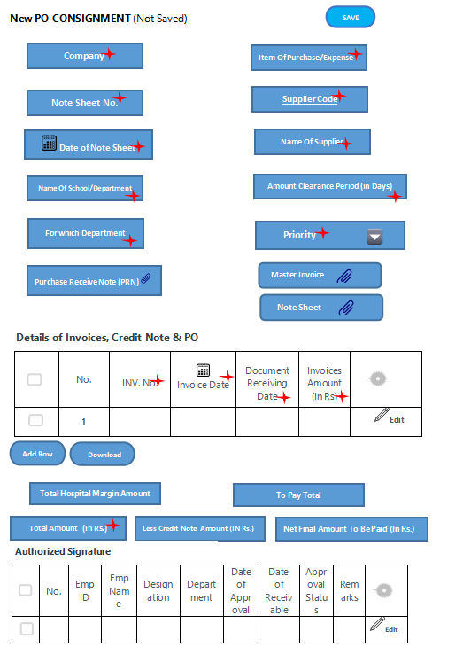

Authorized Signature Table
Sl No | User Role | Click Action | Form Status | Next User Level
1 | consignment store keeper | Save | Draft | consignment store keeper
2 | consignment store keeper | Verify and Save | Verify and Save | consignment store keeper
3 | consignment store keeper | Cancel | Cancelled | consignment store keeper
4 | consignment store keeper | Submit | Verified and Submitted by Note Sheet Creator | Dy. Head , MM
5 | Dy. Head , MM | Approve | Verified and Approved by Dy. Head , MM | GM, MM
6 | Dy. Head , MM | Return and Transfer | Verified and Submitted by Note Sheet Creator | Asst. Store keeper
7 | GM, MM | Approve | Verified and Approved by GM, MM | Accounts Manager
8 | GM, MM | Return and Transfer | Status of the returned user level | Any of the predecessor
9 | Accounts Manager | Approve | Verified and Approved by Accounts Clerk | CFO, KIMS
10 | Accounts Manager | Return and Transfer | Status of the returned user level | Any of the predecessor
11 | CFO, KIMS | Approve | Verified and Approved by CFO | Director Administration
12 | CFO, KIMS | Return and Transfer | Status of the returned user level | Any of the predecessor
13 | Director Administration | Approve | Verified and Approved by Director Administration | Audit User 1
14 | Director Administration | Return and Transfer | Status of the returned user level | Any of the predecessor
15 | Audit User 1 | Approve | Bill Received by Audit User1 | Audit User 2
16 | Audit User 1 | Return and Transfer | Status of the returned user level | Any of the predecessor
17 | Pro-VC | Approve | Approved by Pro- VC | Accounts Clerk
18 | Pro-VC | Return and Transfer | Status of the returned user level | Any of the predecessor
19 | Audit User 2 | Approve | Approved by Audit User 2 | Pro-VC
20 | Accounts Clerk | Approve | Journal Entry by Accounts Clerk | Accounts Clerk
21 | Accounts Clerk | Return and Transfer | Status of the returned user level | Any of the predecessor
22 | Accounts Clerk | Approve | Passed for Payment

Fields of Consignment Screen :
Header Fields
FIELD NAME | FIELD TYPE | Action / Validation
Company | Link Field | Fetched from Company master screen. If logged in user is associated with more than one company then, the field shall give the option to choose ELSE associated company name shall be displayed
Note Sheet No. | Data Field | User entry with alphanumeric field
Date Of Note Sheet | Date | User entry / selection of date
Name Of School/Department | Link Field | Department master screen will have the required data for user selection
For which Department | Link Field | To be fetched from Department master screen
Item Of Purchase/Expense | Data Field | User entry
Supplier Code | Link Field | Fetched from Supplier master screen
Name Of Supplier | Data Field | Auto fetch based on supplier code
Amount Clearance Period (in Days) | Int | Numeric value
Priority | Drop Down  Urgent  High Priority  Normal  Low Priority | User selection
Master Invoice Attachment | Attachment | Only pdf file
Note sheet Attachment | Attachment | Only pdf file

Details of Invoices & PO (Child Table)
Details of Invoices & P.O. | Data Field
Sl.No. | Auto Fill | Auto fill , read only
Invoice No. | Data Field | User entry
Invoice Date | Date | User entry
Document Receiving Date | Date | User entry
Invoices Amount(in Rs) | Currency Field | Only currency
HOSPITAL MARGIN NOTE NO. | Data Field | User entry
HOSPITAL MARGIN NOTE DATE | Date | User selection
HOSPITAL MARGIN AMOUNT | Currency Field | Numeric value
TO-PAY | Data Field | Auto calculated
PATIENT NAME | Data Field | User entry
MRN NO. | Data Field | User entry
Document No. | Data Field | User entry
Document Date | Date | User selection
Vendor code | Link Field | User selection
Requisition form or Indent | Attachment | Only pdf file
Vendor Quotation | Attachment | Only pdf file
Comparative Statement | Attachment | Only pdf file
Approval Sheet | Attachment | Only pdf file
PO | Attachment | Only pdf file
Delivery Challan | Attachment | Only pdf file
Invoice | Attachment | Only pdf file
GRN | Attachment | Only pdf file
Bill Summary | Attachment | Only pdf file
Credit Memo | Attachment | Only pdf file
Purchase Receive Note (PRN) | Attachment | Only pdf file
Others | Attachment | Only pdf file

Details of Invoices & PO (Child Table) Calculation :

- Column “To Pay” = Invoice Amount column value - Hospital Margin Amount column value
- Field Total Amount (In Rs.) = Sum (Invoice Amount) column of all the rows in the table
- Less Credit Note Amount field = Sum (Hospital Margin Amount) of all the rows in the table
- Field “To Pay Total” = Sum (To Pay) column of all the rows in the table
- Field “Net Final Amount to be Paid (In Rs.)” = Field “Total Amount (In Rs.) - field “Less Credit Note Amount”

Authorized Signature Table
Sl NO. | Auto Fill | Auto Fill
Emp ID | Link Field | Auto Fill
Emp Name | Data Field | Auto Fill
Designation | Data Field | Auto Fill
Date of Approval | Date | Auto Fill
Date of Receivable | Date | Auto Fill
Department | Link Field | Auto Fill
Remarks | Data Field | Auto Fill
Approval Status | Data Field | Auto Fill
Transfer to | Data Field | Auto Fill
Disapproval Check | Data Field | Auto Fill
Disapproval Emp | Data Field | Auto Fill
Disapproval Emp Name | Data Field | Auto Fill
Single user | Data Field | Auto Fill

Workflow Diagram

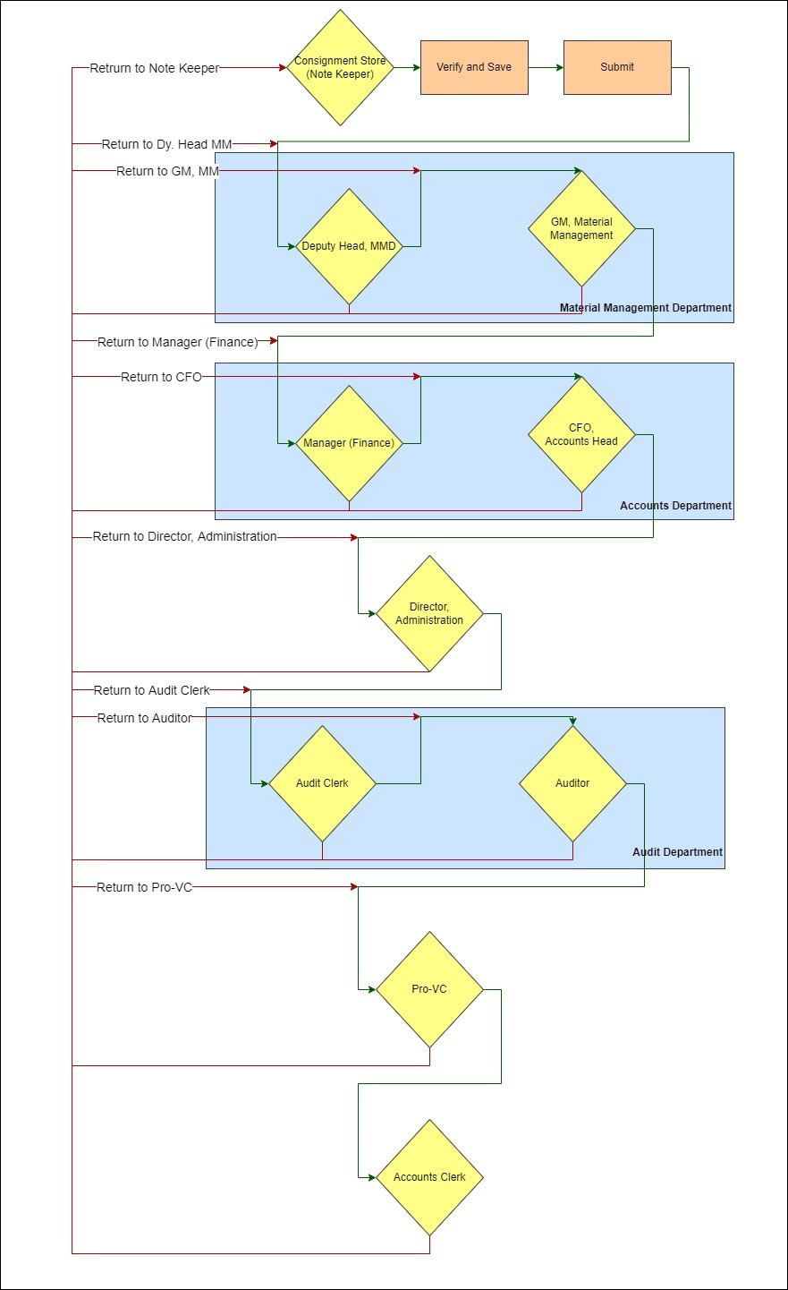

PO Material Management Workflow:

UI
The process of Store Officer (Note Sheet Keeper) submission , approval and cancellation of note sheet shall be same as steps (a) to (m) of Section 8.1.1
and (a) to (c) of Section 8.1.2

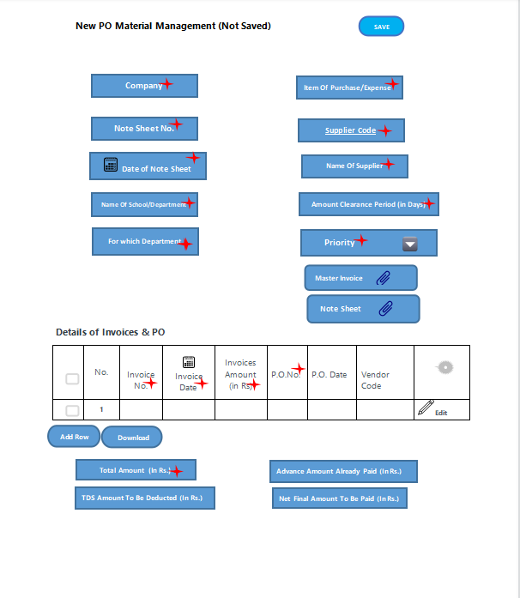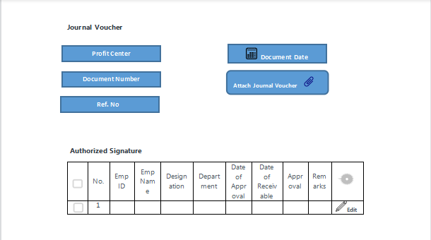

Authorized Signature Table
Sl No | User Role | Click Action | Form Status | Next User Level
1 | Store Officer | Save | Draft | Store Officer
2 | Store Officer | Verify and Save | Verify and Save | Store Officer
3 | Store Officer | Cancel | Cancelled | Store Officer
4 | Store Officer | Submit | Verified and Submitted by Note Sheet Creator | GM, MM
5 | GM, MM | Approve | Verified and Approved by GM, MM | Accounts Clerk
8 | GM, MM | Return and Transfer | Status of the returned user level | Any of the predecessor
9 | Accounts Clerk | Approve | Verified and Approved by Accounts Clerk | CFO, KIMS
10 | Accounts Clerk | Return and Transfer | Status of the returned user level | Any of the predecessor
11 | CFO, KIMS | Approve | Verified and Approved by CFO | Director Administration
12 | CFO, KIMS | Return and Transfer | Status of the returned user level | Any of the predecessor
13 | Director Administration | Approve | Verified and Approved by Director Administration | Audit User 1
14 | Director Administration | Return and Transfer | Status of the returned user level | Any of the predecessor
15 | Audit User 1 | Approve | Approved by Audit User 1 | Audit User 2
16 | Audit User 1 | Return and Transfer | Status of the returned user level | Any of the predecessor
17 | Pro-VC | Approve | Approved by Pro- VC | Accounts Clerk
18 | Pro-VC | Return and Transfer | Status of the returned user level | Any of the predecessor
19 | Audit User 2 | Approve | Bill Received by Audit User1 | Pro-VC
20 | Audit User 2 | Return and Transfer | Status of the returned user level | Any of the predecessor
21 | Accounts Clerk | Approve | Journal Entry by Accounts Clerk | Accounts Clerk
22 | Accounts Clerk | Approve | Passed for Payment

Fields of Material Management Screen :
Header Fields
FIELD NAME | FIELD TYPE | Action / Validation
Company | Link Field | Fetched from Company master screen. If logged in user is associated with more than one company then, the field shall give the option to choose ELSE associated company name shall be displayed
Note Sheet No. | Data Field | User entry
Date Of Note Sheet | Date | User selection
Name Of School/Department | Link Field | User selection, Fetched from Department master screen based on logged in user
For which Department | Link Field | User selection
Item Of Purchase/Expense | Data Field | User entry
Supplier Code | Link Field | Fetched from Supplier master screen
Name Of Supplier | Data Field | Fetched based on selected supplier code
Amount Clearance Period (in Days) | Int | Numeric value only
Priority | Drop Down  Urgent  High Priority  Normal  Low Priority | User selection
Master Invoice Attachment | Attachment | PDF file only
Note sheet Attachment | Attachment | PDF file only
Details of Invoices & PO (Child Table)
Sl.No. | Auto Fill | Auto fill , read only
Invoice No. | Data Field | User entry (alphanumeric)
Invoice Date | Date | User selection
Invoices Amount(in Rs) | Currency Field | Numeric value only
P.O. No. | Data Field | User entry
P.O. Date | Date Field | User selection
Vendor code | Link Field | Fetched from Supplier master screen
Requisition form or Indent | Attachment | PDF file only
Vendor Quotation | Attachment | PDF file only
Comparative Statement | Attachment | PDF file only
Approval Sheet | Attachment | PDF file only
PO | Attachment | PDF file only
Delivery Challan | Attachment | PDF file only
Invoice | Attachment | PDF file only
GRN | Attachment | PDF file only
Bill Summary | Attachment | PDF file only
Credit Memo | Attachment | PDF file only
Others | Attachment | PDF file only
Authorized Signature Table
Sl NO. | Auto Fill | Auto Fill, read only
Emp ID | Link Field | Auto Fill, read only
Emp Name | Data Field | Auto Fill, read only
Designation | Data Field | Auto Fill, read only
Date of Approval | Date | Auto Fill, read only
Date of Receivable | Date | Auto Fill, read only
Department | Link Field | Auto Fill, read only
Remarks | Data Field | Auto Fill, read only
Approval Status | Data Field | Auto Fill, read only
Transfer to | Data Field | Auto Fill, read only
Disapproval Check | Data Field | Auto Fill, read only
Disapproval Emp | Data Field | Auto Fill, read only
Disapproval Emp Name | Data Field | Auto Fill, read only
Single user | Data Field | Auto Fill, read only

Note :

Details of Invoices & PO (Child Table) Calculation :

- User shall see all the attachment fields on click of 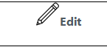 the pencil icon of Details of Invoices & PO (Child Table)

- Field Total Amount (In Rs.) = Sum (Invoices Amount) column of all the rows in the table

- Net Final Amount to be Paid (In Rs.) = Total Amount (In Rs.) - [Advance Amount Already Paid (In Rs.) + Advance Amount Already Paid (In Rs.) ]

11.4 Workflow Diagram
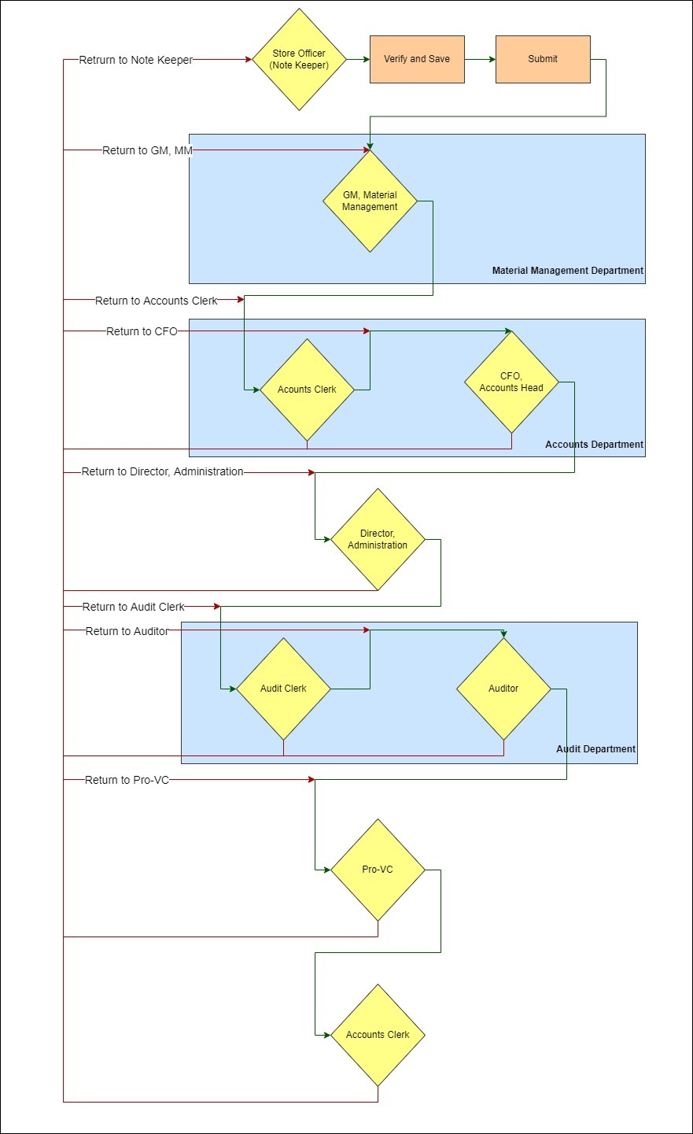

Non PO Contract Workflow:

UI
The process of (Note Sheet Keeper) submission , approval and cancellation of note sheet shall be same as steps (a) to (m) of Section 8.1.1 and (a) to (c) of Section 8.1.2

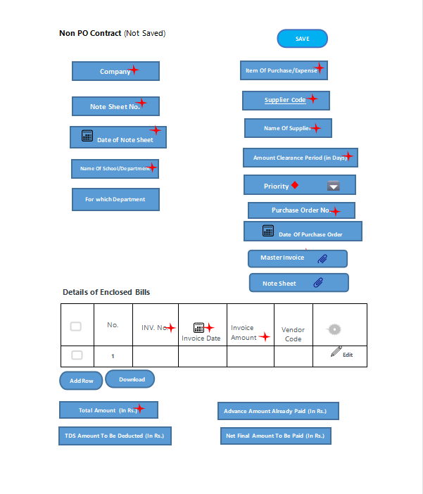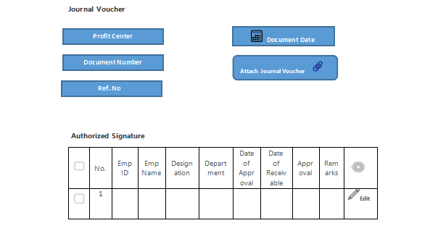

Authorized Signature Table
Sl No | User Role | Click Action | Form Status | Next User Level
1 | Accounts Clerk | Save | Draft | Accounts Clerk
2 | Accounts Clerk | Verify and Save | Verify and Save | Accounts Clerk
3 | Accounts Clerk | Cancel | Cancelled | Accounts Clerk
4 | Accounts Clerk | Submit | Verified and Submitted by Note Sheet Creator | CFO, KIMS
5 | CFO, KIMS | Approve | Verified and Approved by CFO | Director Administration
6 | CFO, KIMS | Return and Transfer | Status of the returned user level | Any of the predecessor
7 | Director Administration | Approve | Verified and Approved by Director Administration | Audit User 1
8 | Director Administration | Return and Transfer | Status of the returned user level | Any of the predecessor
9 | Audit User 1 | Approve | Bill Received by Audit User1 | Audit User 2
10 | Audit User 1 | Return and Transfer | Status of the returned user level | Any of the predecessor
11 | Pro-VC | Approve | Approved by Pro- VC | Accounts Clerk
12 | Pro-VC | Return and Transfer | Status of the returned user level | Any of the predecessor
13 | Audit User 2 | Approve | Approved by Audit User 2 | Pro-VC
14 | Audit User 2 | Return and Transfer | Status of the returned user level | Any of the predecessor
15 | Accounts Clerk | Approve | Journal Entry by Accounts Clerk | Accounts Clerk
16 | Accounts Clerk | Approve | Passed for Payment

Fields of Non PO contract Screen :
Header Section
FIELD NAME | FIELD TYPE | Action / Validation
Company | Link Field | Fetched from Company master screen. If logged in user is associated with more than one company then, the field shall give the option to choose ELSE associated company name shall be displayed
Note Sheet No. | Data Field | User entry
Date Of Note Sheet | Date | User selection
Name Of School/Department | Link Field | User selection, Fetched from Department master screen based on logged in user
For which Department | Link Field | User selection
Item Of Purchase/Expense | Data Field | User entry
Supplier Code | Link Field | Fetched from Supplier master screen
Name Of Supplier | Data Field | Fetched based on selected supplier code
Amount Clearance Period (in Days) | Int | Numeric value only
Priority | Drop Down  Urgent  High Priority  Normal  Low Priority | User selection
Purchase Order No | Data Field | User entry
Date of Purchase Order | Date | User selection
Master Invoice Attachment | Attachment | PDF File
Note sheet Attachment | Attachment | PDF File

Details of Enclosed Bills (Child Table)
Sl.No. | Auto Fill | Auto fill , read only
INV. No. | Data Field | User entry
Invoice Date | Date | User selection
Invoice Amount | Currency Field | Numeric value only
Vendor code | Link Field | Fetched from Supplier master screen
Remarks, If Any | Data Field | User entry
Requisition form or Indent | Attachment | PDF File
Vendor Quotation | Attachment | PDF File
Comparative Statement | Attachment | PDF File
Approval Sheet | Attachment | PDF File
PO | Attachment | PDF File
Delivery Challan | Attachment | PDF File
Invoice | Attachment | PDF File
GRN | Attachment | PDF File
Bill Summary | Attachment | PDF File
Credit Memo | Attachment | PDF File
Others | Attachment | PDF File

- Field Total Amount (In Rs.) = Sum (Invoices Amount) column of all the rows in the table

- Net Final Amount to be Paid (In Rs.) = Total Amount (In Rs.) - [Advance Amount Already Paid (In Rs.) + Advance Amount Already Paid (In Rs.) ]

Authorized Signature Table
Sl NO. | Auto Fill | Auto Fill, read only
Emp ID | Link Field | Auto Fill, read only
Emp Name | Data Field | Auto Fill, read only
Designation | Data Field | Auto Fill, read only
Date of Approval | Date | Auto Fill, read only
Date of Receivable | Date | Auto Fill, read only
Department | Link Field | Auto Fill, read only
Remarks | Data Field | Auto Fill, read only
Approval Status | Data Field | Auto Fill, read only
Transfer to | Data Field | Auto Fill, read only
Disapproval Check | Data Field | Auto Fill, read only
Disapproval Emp | Data Field | Auto Fill, read only
Disapproval Emp Name | Data Field | Auto Fill, read only
Single user | Data Field | Auto Fill, read only

Workflow Diagram
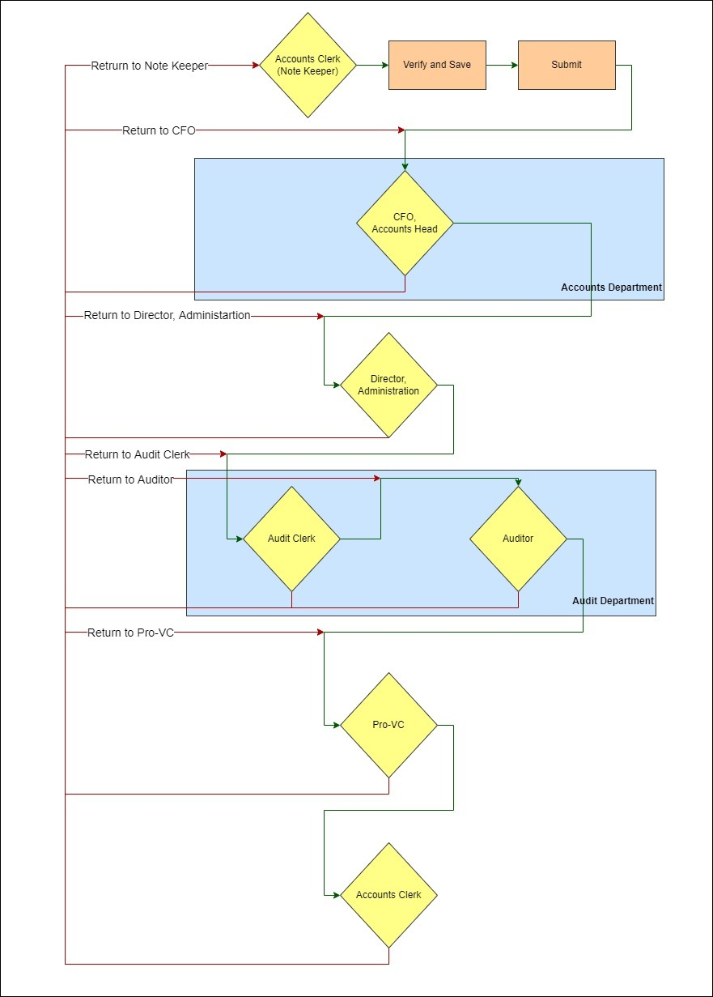

Non PO Non-contract Workflow:

UI
The process of (Note Sheet Keeper) submission , approval and cancellation of note sheet shall be same as steps (a) to (m) of Section 8.1.1 and (a) to (c) of Section 8.1.2

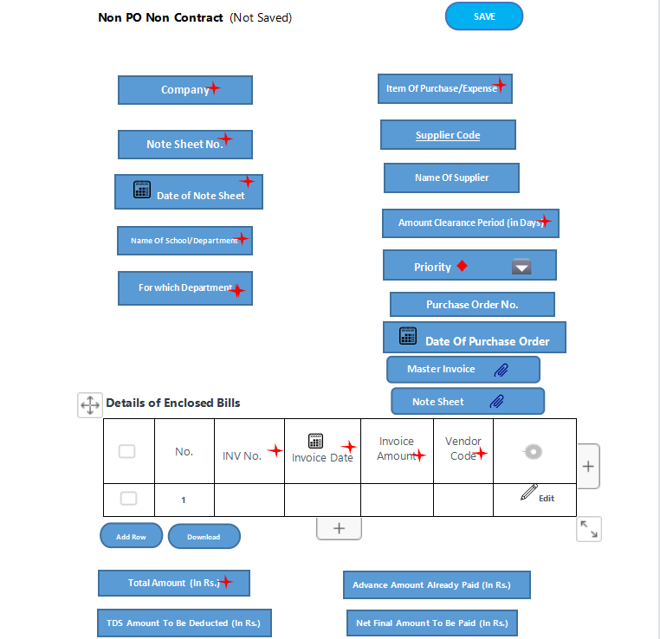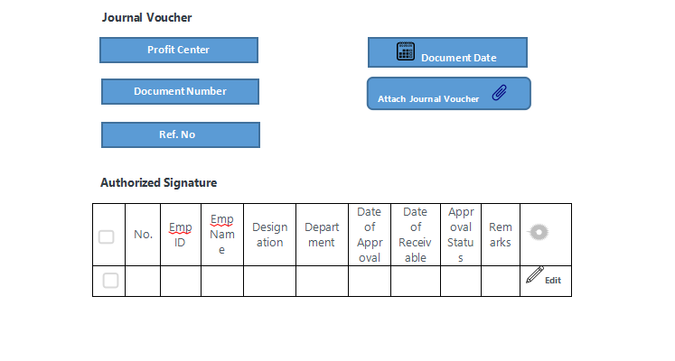

Authorized Signature Table
Sl No | User Role | Click Action | Form Status | Next User Level
1 | Accounts Clerk | Save | Draft | Accounts Clerk
2 | Accounts Clerk | Verify and Save | Verify and Save | Accounts Clerk
3 | Accounts Clerk | Cancel | Cancelled | Accounts Clerk
4 | Accounts Clerk | Submit | Verified and Submitted by Note Sheet Creator | CFO, KIMS
5 | CFO, KIMS | Approve | Verified and Approved by CFO | Director Administration
6 | CFO, KIMS | Return and Transfer | Status of the returned user level | Any of the predecessor
7 | Director Administration | Approve | Approved by Director Administration | Medical Superintendent
8 | Director Administration | Return and Transfer | Status of the returned user level | Any of the predecessor
9 | Medical Superintendent | Approve | Approved by Medical Superintendent | Audit User 1
10 | Medical Superintendent | Return and Transfer | Status of the returned user level | Any of the predecessor
11 | Audit User 1 | Approve | Bill Received by Audit User1 | Audit User 2
12 | Audit User 1 | Return and Transfer | Status of the returned user level | Any of the predecessor
13 | Pro-VC | Approve | Approved by Pro- VC | Accounts Clerk
14 | Pro-VC | Return and Transfer | Status of the returned user level | Any of the predecessor
15 | Audit User 2 | Approve | Approved by Audit User 2 | Pro-VC
16 | Audit User 2 | Return and Transfer | Status of the returned user level | Any of the predecessor
17 | Accounts Clerk | Approve | Journal Entry by Accounts Clerk | Accounts Clerk
18 | Accounts Clerk | Approve | Passed for Payment

Fields of Non PO Non Contract Screen :
Header Section
FIELD NAME | FIELD TYPE | Action / Validation
Company | Link Field | Fetched from Company master screen. If logged in user is associated with more than one company then, the field shall give the option to choose ELSE associated company name shall be displayed
Note Sheet No. | Data Field | User entry
Date Of Note Sheet | Date | User selection / entry of date
Name Of School/Department | Link Field | User selection, Fetched from Department master screen based on logged in user
For which Department | Link Field | Fetched from Department master screen for user selection
Item Of Purchase/Expense | Data Field | User entry
Supplier Code | Link Field | Fetched from Supplier master screen
Name Of Supplier | Data Field | Fetched based on selected supplier code and read only
Amount Clearance Period (in Days) | Int | Numeric value only
Priority | Drop Down  Urgent  High Priority  Normal  Low Priority | User selection
Purchase Order No | Data Field | User entry
Date of Purchase Order | Date | User selection
Master Invoice Attachment | Attachment | PDF File
Note sheet Attachment | Attachment | PDF File

Details of Enclosed Bills (Child Table)
Sl.No. | Auto Fill | Auto fill , read only
INV. No. | Data Field | User entry
Invoice Date | Date | User selection
Invoice Amount | Currency Field | Numeric value only
Vendor code | Link Field | Fetched from Supplier master screen
Remarks, If Any | Data Field | User entry
Requisition form or Indent | Attachment | PDF File
Vendor Quotation | Attachment | PDF File
Comparative Statement | Attachment | PDF File
Approval Sheet | Attachment | PDF File
PO | Attachment | PDF File
Delivery Challan | Attachment | PDF File
Invoice | Attachment | PDF File
GRN | Attachment | PDF File
Bill Summary | Attachment | PDF File
Credit Memo | Attachment | PDF File
Others | Attachment | PDF File

- Field Total Amount (In Rs.) = Sum (Invoices Amount) column of all the rows in the table

- Net Final Amount to be Paid (In Rs.) = Total Amount (In Rs.) - [Advance Amount Already Paid (In Rs.) + Advance Amount Already Paid (In Rs.) ]

Authorized Signature Table
Sl NO. | Auto Fill | Auto fill
Emp ID | Link Field | Auto fill
Emp Name | Data Field | Auto fill
Designation | Data Field | Auto fill
Date of Approval | Date | Auto fill
Date of Receivable | Date | Auto fill
Department | Link Field | Auto fill
Remarks | Data Field | Auto fill
Approval Status | Data Field | Auto fill
Transfer to | Data Field | Auto fill
Disapproval Check | Data Field | Auto fill
Disapproval Emp | Data Field | Auto fill
Disapproval Emp Name | Data Field | Auto fill
Single user | Data Field | Auto fill

13.4 Workflow Diagram
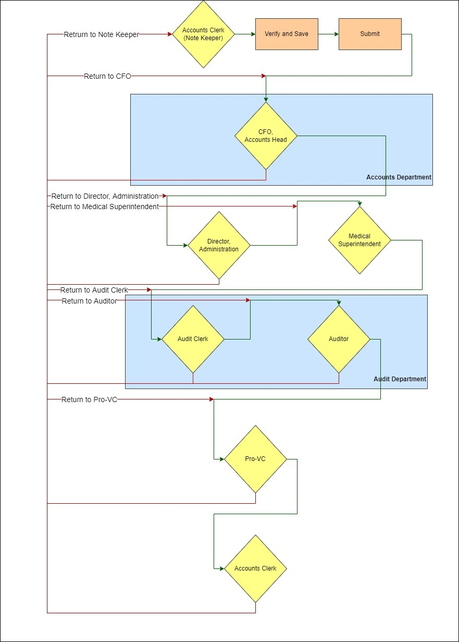

Pharmacy Workflow:

14.1 UI
The process of Manager Lobby (Note Sheet Keeper) submission , approval and cancellation of note sheet shall be same as steps (a) to (m) of Section 8.1.1 and (a) to (c) of Section 8.1.2

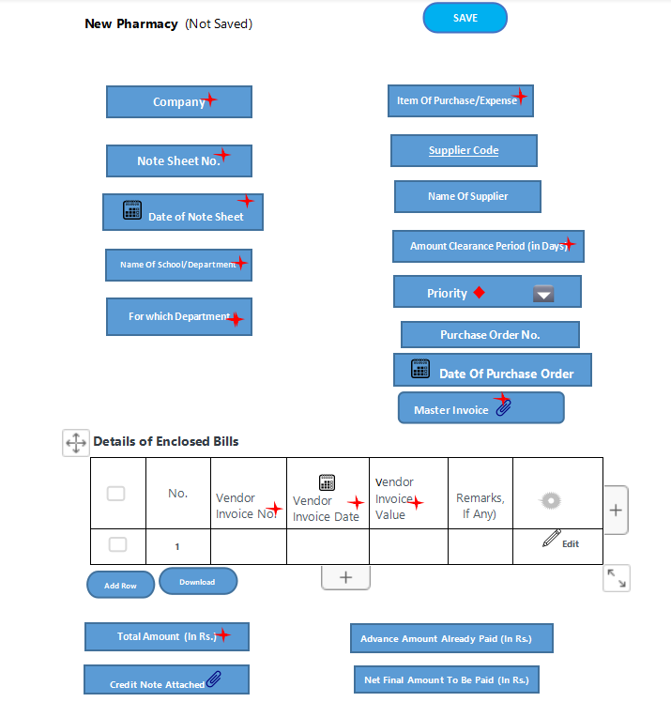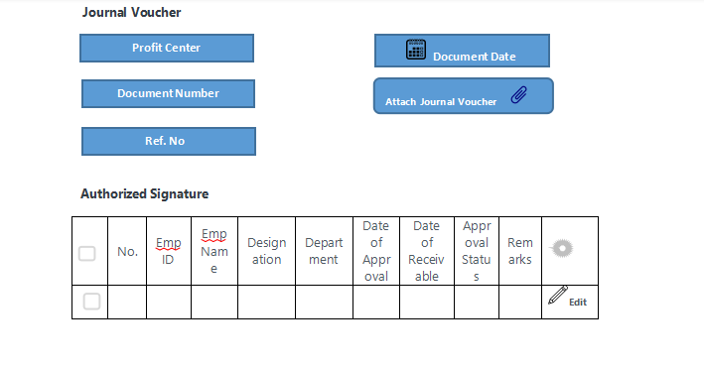

14.2 Authorized Signature Table
Sl No | User Role | Click Action | Form Status | Next User Level
1 | note sheet creator | Save | Draft | note sheet creator
2 | note sheet creator | Verify and Save | Verify and Save | note sheet creator
3 | note sheet creator | Cancel | Cancelled | note sheet creator
4 | note sheet creator | Submit | Verified and Submitted by Note Sheet Creator | GM, Pharmacy
5 | GM, Pharmacy | Approve | Approved by GM, Pharmacy | Manager, Accounts
6 | GM, Pharmacy | Return and Transfer | Status of the returned user level | Any of the predecessor
7 | Manager , Accounts | Approve | Approved by Manager , Accounts | CFO, KIMS
8 | Manager , Accounts | Return and Transfer | Status of the returned user level | Any of the predecessor
9 | CFO, KIMS | Approve | Verified and Approved by CFO | Director Administration
10 | CFO, KIMS | Return and Transfer | Status of the returned user level | Any of the predecessor
11 | Director Administration | Approve | Approved by Director Administration | Audit User 1
12 | Director Administration | Return and Transfer | Status of the returned user level | Any of the predecessor
13 | Audit User 1 | Approve | Bill Received by Audit | Audit User 2
16 | Audit User 1 | Return and Transfer | Status of the returned user level | Any of the predecessor
17 | Pro-VC | Approve | Approved by Pro- VC | Accounts Clerk
18 | Pro-VC | Return and Transfer | Status of the returned user level | Any of the predecessor
17 | Audit User 2 | Approve | Approved by Audit User 2 | Pro-VC
18 | Accounts Clerk | Approve | Journal Entry by Accounts Clerk | Accounts Clerk
19 | Accounts Clerk | Approve | Passed for Payment

14.3 Fields of Pharmacy Screen :
Header Section
FIELD NAME | FIELD TYPE | Action / Validation
Company | Link Field | Fetched from Company master screen. If logged in user is associated with more than one company then, the field shall give the option to choose ELSE associated company name shall be displayed
Note Sheet No. | Data Field | User entry
Date Of Note Sheet | Date | User selection
Name Of School/Department | Link Field | User selection, Fetched from Department master screen based on logged in user
For which Department | Link Field | User selection, Fetched from Department master screen
Item Of Purchase/Expense | Data Field | User entry
Supplier Code | Link Field | Fetched from Supplier master screen
Name Of Supplier | Data Field | Fetched based on supplier code
Amount Clearance Period (in Days) | Int | Numeric value only
Priority | Drop Down  Urgent  High Priority  Normal  Low Priority | User selection
Purchase Order No | Data Field | User entry
Date of Purchase Order | Date | User selection
Master Invoice Attachment | Attachment | PDF file
Note sheet Attachment | Attachment | PDF file

Details of Enclosed Bills (Child Table)
Sl.No. | Auto Fill | Auto fill , read only
Vendor Invoice No | Data Field | User entry
Vendor Invoice Date | Date | User selection
Vendor Invoice Value | Currency Field | Numeric value only
Remarks, If Any | Data Field | User entry
Requisition form or Indent | Attachment | PDF File
Vendor Quotation | Attachment | PDF File
Comparative Statement | Attachment | PDF File
Approval Sheet | Attachment | PDF File
PO | Attachment | PDF File
Delivery Challan | Attachment | PDF File
Invoice | Attachment | PDF File
GRN | Attachment | PDF File
Bill Summary | Attachment | PDF File
Credit Memo | Attachment | PDF File
Purchase Receipt Note | Attachment | PDF File
Others | Attachment | PDF File

Note :

Details of Enclosed Bills (Child Table) Calculation :

- User shall see all the attachment fields on click of the pencil icon of Details of Enclosed Bills (Child Table)

- Field Total Amount (In Rs.) = Sum (Vendor Invoice Value) column of all the rows in the table

- Net Final Amount to be Paid (In Rs.) = Total Amount (In Rs.) - Advance Amount Already Paid (In Rs.)

Authorized Signature Table
Sl NO. | Auto Fill | Auto fill , read only
Emp ID | Link Field | Auto fill , read only
Emp Name | Data Field | Auto fill , read only
Designation | Data Field | Auto fill , read only
Date of Approval | Date | Auto fill , read only
Date of Receivable | Date | Auto fill , read only
Department | Link Field | Auto fill , read only
Remarks | Data Field | Auto fill , read only
Approval Status | Data Field | Auto fill , read only
Transfer to | Data Field | Auto fill , read only
Disapproval Check | Data Field | Auto fill , read only
Disapproval Emp | Data Field | Auto fill , read only
Disapproval Emp Name | Data Field | Auto fill , read only
Single user | Data Field | Auto fill , read only

14.4 Work flow Diagram

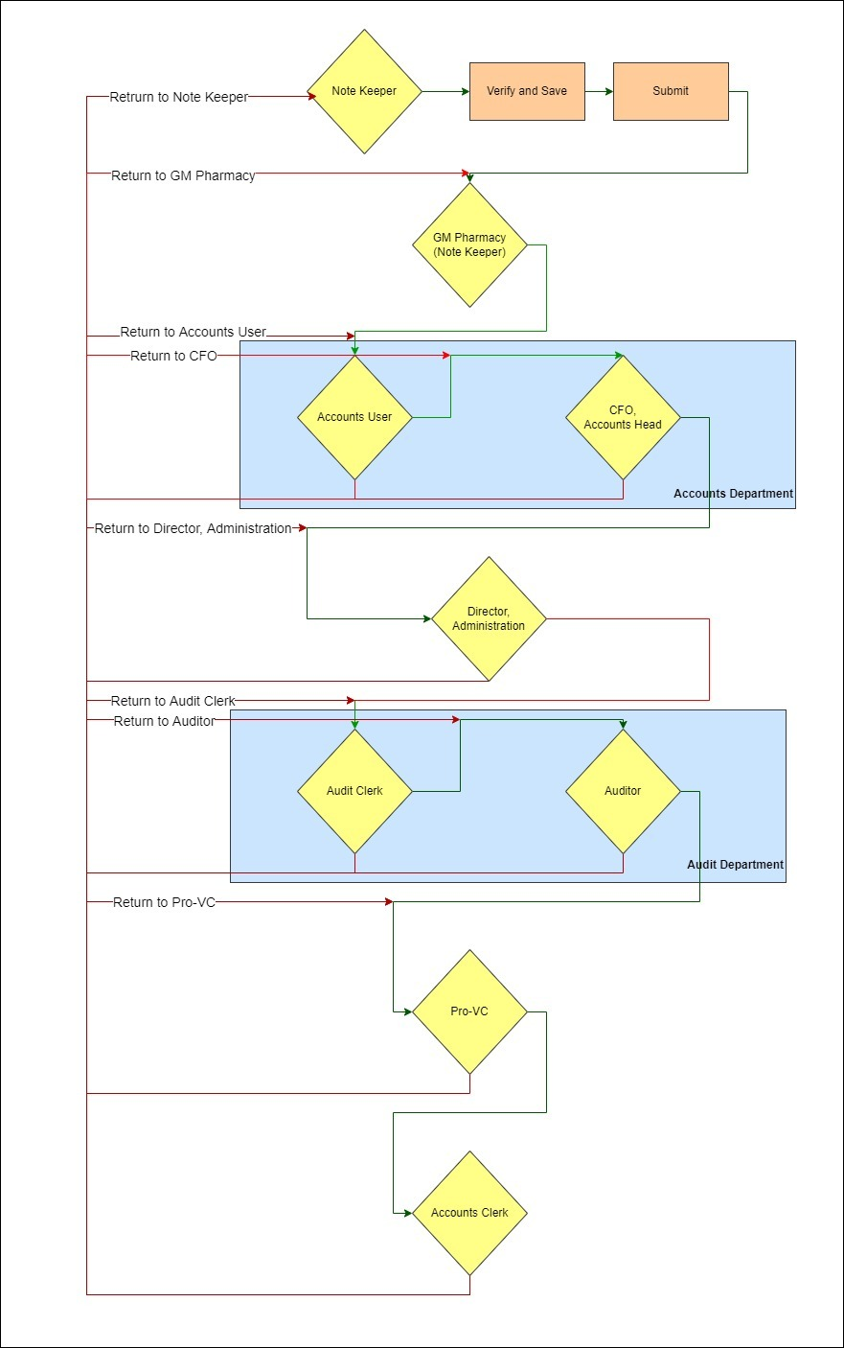

Patient Refund Workflow:

15.1 UI
The process of Manager Lobby (Note Sheet Keeper) submission , approval and cancellation of note sheet shall be same as steps (a) to (m) of Section 8.1.1 and (a) to (c) of Section 8.1.2
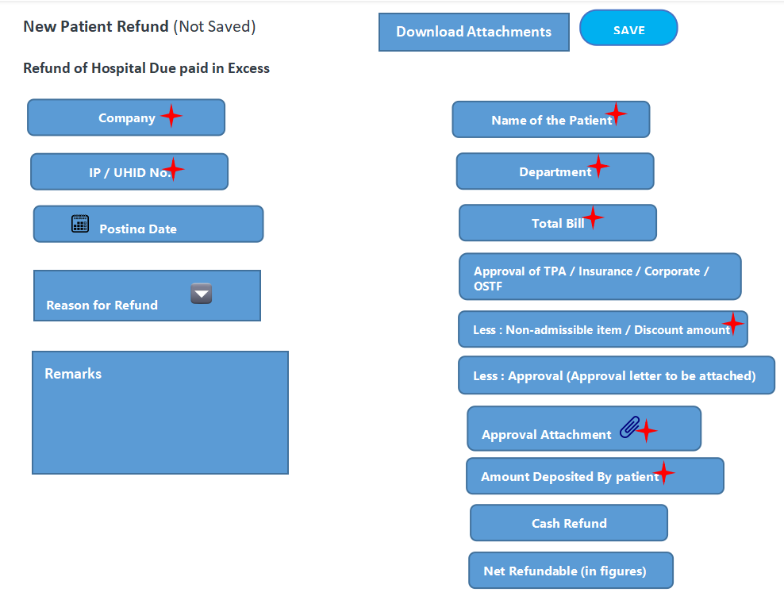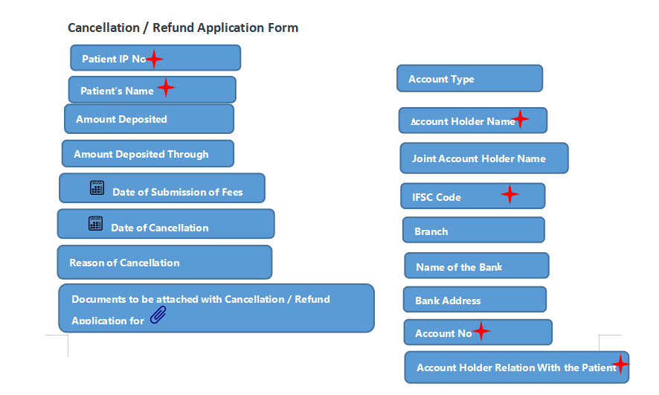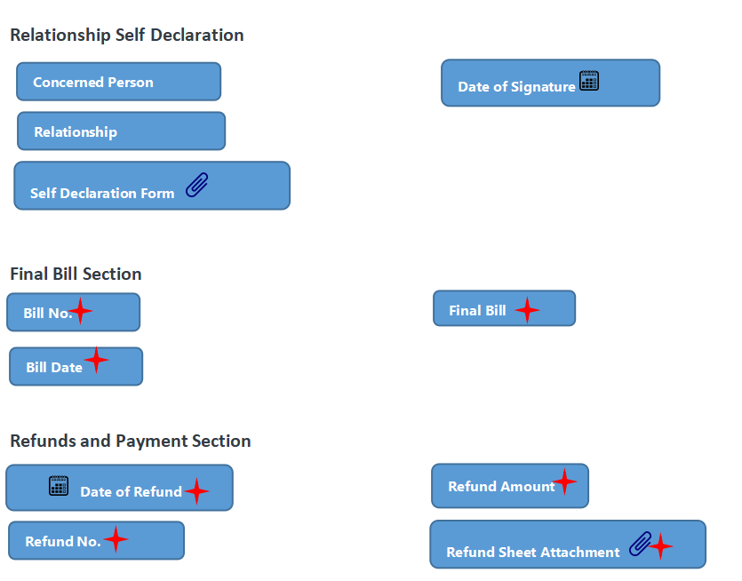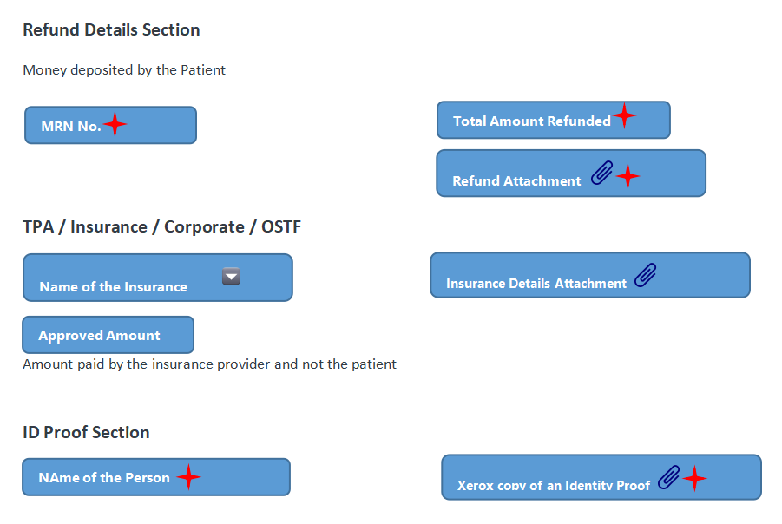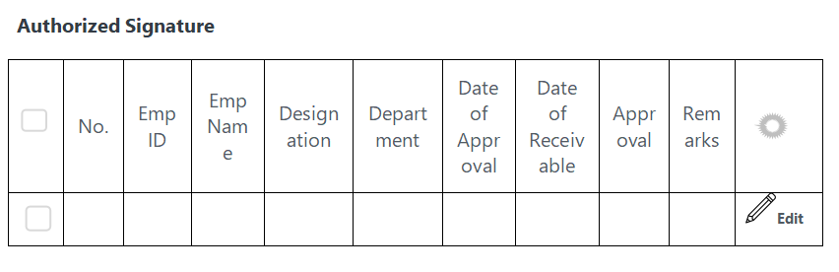

15.2 Authorized Signature Table
Sl No | User Role | Click Action | Form Status | Next User Level
1 | Manager Lobby | Save | Draft | Manager Lobby
2 | Manager Lobby | Verify and Save | Verify and Save | Manager Lobby
3 | Manager Lobby | Cancel | Cancelled | Manager Lobby
4 | Manager Lobby | Submit | Verified and Submitted by Note Sheet Creator | Director, OPS
5 | Director, OPS | Approve | Approved By Director, OPS | Medical Superintendent
6 | Director, OPS | Return and Transfer | Status of the returned user level | Any of the predecessor
7 | Medical Superintendent | Approve | Approved By Medical Superintendent | Accounts Clerk
8 | Medical Superintendent | Return and Transfer | Status of the returned user level | Any of the predecessor
9 | Accounts Clerk | Approve | Approved by Accounts Clerk | CFO, KIMS
10 | Accounts Clerk | Return and Transfer | Status of the returned user level | Any of the predecessor
11 | CFO, KIMS | Approve | Approved By CFO Accounts | Accounts Clerk
12 | CFO, KIMS | Return and Transfer | Status of the returned user level | Any of the predecessor
13 | Accounts Clerk | Approve | Passed for Payment

15.3 Fields of Patient Refund Screen :

Refund of Hospital Due paid in Excess
FIELD NAME | FIELD TYPE | Validation
Company | Link Field
Name of the Patient | Data Field | User entry
IP / UHID No. | Data Field | User entry
Department | Data Field | User selection, Fetched from Department master screen based on logged in user
Posting Date | Date field | Auto fetch based on saving the form, read only
Reason for Refund | Link Field | Values fetched from master screen
Total Bill | Currency | Calculated field, only numeric
Approval of TPA / Insurance / Corporate / OSTF | Data Field | User entry, only numeric
Less : Non-admissible item / Discount amount | Currency | User entry, only numeric
Less : Approval (Approval letter to be attached) | Currency | User entry, only numeric
Approval Attachment | Attachment | User will upload PDF file
Amount Deposited By patient | Currency | User entry, only numeric
Cash Refund | Currency | User entry, only numeric
Net Refundable (in figures) | Currency | Calculated field, only numeric
Net Refundable (in words) | Data Field | Auto fill
Posting Date | Date | User selection, date
Remarks | Data Field | User entry

15.4 Net Refundable Calculation
X1 = Total Bill minus Approval of TPA/Insurance/Corporate/OSTF minus Non-admissible item / Discount amount minus Less : Approval (Approval letter to be attached)

X2 = Amount Deposited by patient - Cash Refund

Net Refundable = X2 - X1

Cancellation / Refund Application Form
FIELD NAME | FIELD TYPE | Validation
Patient IP No | Data field, read only | Auto fetch based on IP / UHID No. Field value of Refund of Hospital Due paid in Excess section
Patient's Name | Data field | Auto fetch based on Name of the Patient field of Refund of Hospital Due paid in Excess section
Amount Deposited | Currency | User entry, only numeric
Account Type | Data Field | User entry
Amount Deposited Through | Data Field | User entry
Account Holder Name | Data Field | User entry
Date of Submission of Fee | Date | User selection, date
Joint Account Holder Name | Data Field | User entry
Date of Cancellation | Date | User selection, date
IFSC Code | Data Field | Alphanumeric, max length 11 digit
Branch | Read Only | Auto fetch based on IFSC Code
Name of the Bank | Read Only | Auto fetch based on IFSC Code
Bank Address | Read Only | Auto fetch based on IFSC Code
Reason of Cancellation | Data Field | User entry
Account No. | Int | User entry, numeric
Account Holder Relation with the Patient | Data Field | User entry of alphanumeric
Documents to be attached with Cancellation / Refund Application for | Attachment | User will upload PDF file

Relationship Self Declaration
FIELD NAME | FIELD TYPE | Validation
Concern Person | Data Field | User entry
Date of Signature | Date | User selection, date
Relationship | Data Field | User entry
Self Declaration Form | Attachment | User will upload PDF file

Final Bill Section
FIELD NAME | FIELD TYPE | Validation
Bill No | Data Field | User entry
Bill Date | Date | User selection, date
Final Bill | Attachment | User will upload PDF file

Refunds and payments Section
FIELD NAME | FIELD TYPE | Validation
Date of Refund | Date | User selection, date
Refund Amount | Currency | Auto fetch based on net refundable in figures field
Refund No. | Date | User selection, date
Refund Sheet Attachment | Attachment | User will upload PDF file

Refund details Section
FIELD NAME | FIELD TYPE | Validation
MRN No. | Data Field | User entry
Total Amount Refunded | Currency | Auto fetch from Net Refundable
Refund Attachment | Attachment | User will upload PDF file

TPA / Insurance / Corporate / OSTF
FIELD NAME | FIELD TYPE | Validation
Name of Insurance | Drop Down | User selection
Approved Amount | Currency | User entry
Insurance Details Attachment | Attachment | User will upload PDF file

ID Proof Section
FIELD NAME | FIELD TYPE | Validation
Name of the Person | Data Field | User entry
Xerox Copy of any identity Proof | Attachment | User will upload PDF file

Authorized Signature Table
Sl NO. | Auto Fill | Auto fill , read only
Emp ID | Link Field | Auto fill , read only
Emp Name | Data Field | Auto fill , read only
Designation | Data Field | Auto fill , read only
Date of Approval | Date | Auto fill , read only
Date of Receivable | Date | Auto fill , read only
Department | Link Field | Auto fill , read only
Remarks | Data Field | Auto fill , read only
Approval Status | Data Field | Auto fill , read only
Transfer to | Data Field | Auto fill , read only
Disapproval Check | Data Field | Auto fill , read only
Disapproval Emp | Data Field | Auto fill , read only
Disapproval Emp Name | Data Field | Auto fill , read only
Single user | Data Field | Auto fill , read only

15.5 Work Flow diagram

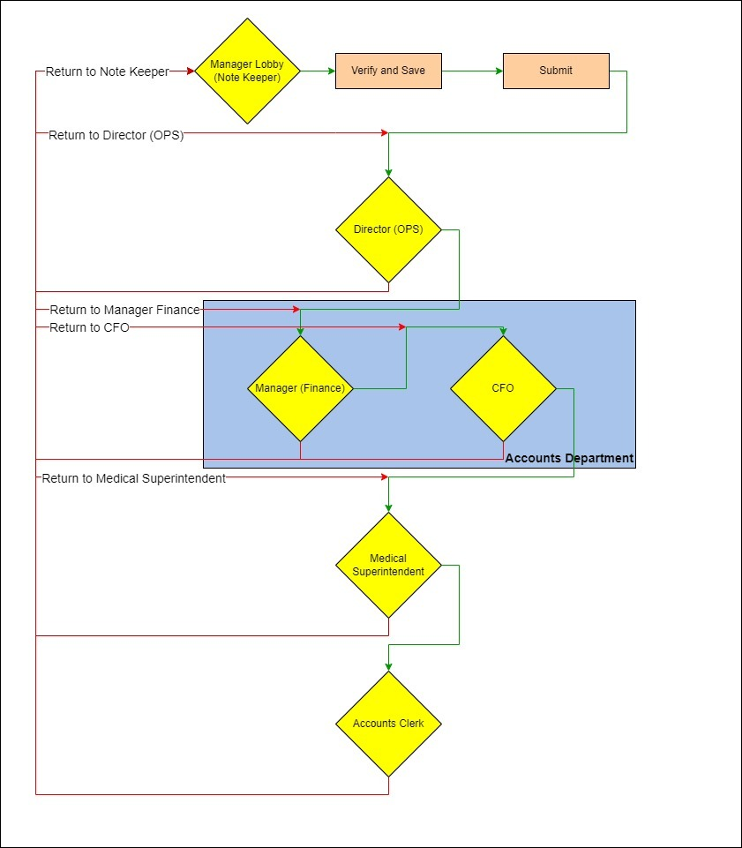

Return and Transfer to Third Party
At any given point of time, in the normal workflow of Invoices , user shall have the option to get the note sheet verified and approved by another Department (which will not be part of the workflow) Approval Committee.

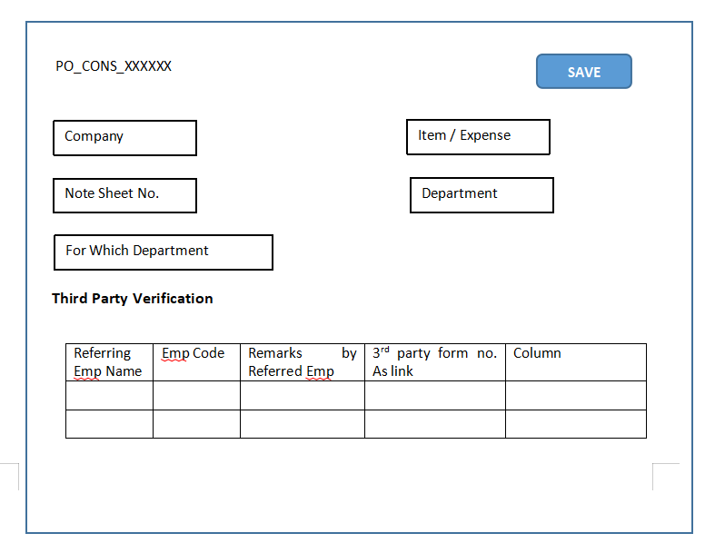
Figure : Note Sheet Form

- In the normal Invoice work flow, user shall enter the following and click SAVE button :

- Referring Emp Name
- Emp Code
- Remarks by the Referred Emp

- On click of SAVE button, system shall navigate to third party department screen (as shown below)

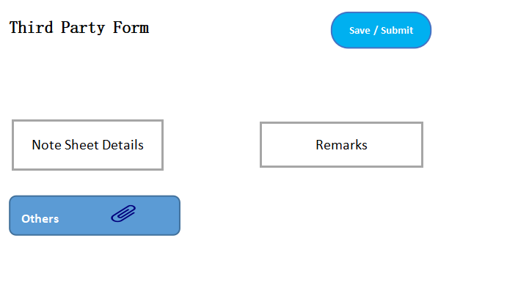

- Unless the verification and approval is not done by third party, invoice work flow (Invoice form) shall be read only
- Third party approval committee shall verify and attach the relevant documents
- Approval committee shall Save and Submit the form
- The system shall navigate back to the Invoice workflow (point where the 3rd party screen was triggered)
- Email shall be triggered to Third party when user decides to redirect the workflow to third party for approval
- Post approval by third party, email shall be triggered to user level who had initiated the third party approval
- In Third party verification table of Invoice form, the third party form number will shall be a link so that user can navigate to the corresponding screen

Batch Payment Workflow
- Entry Point - :
Invoice status “Passed for Payment”
Batch of Invoices that are unpaid

- Accounts User Action
- Accounts User shall enter data to the following fields in UI :

- Company
- Fields of Account Section

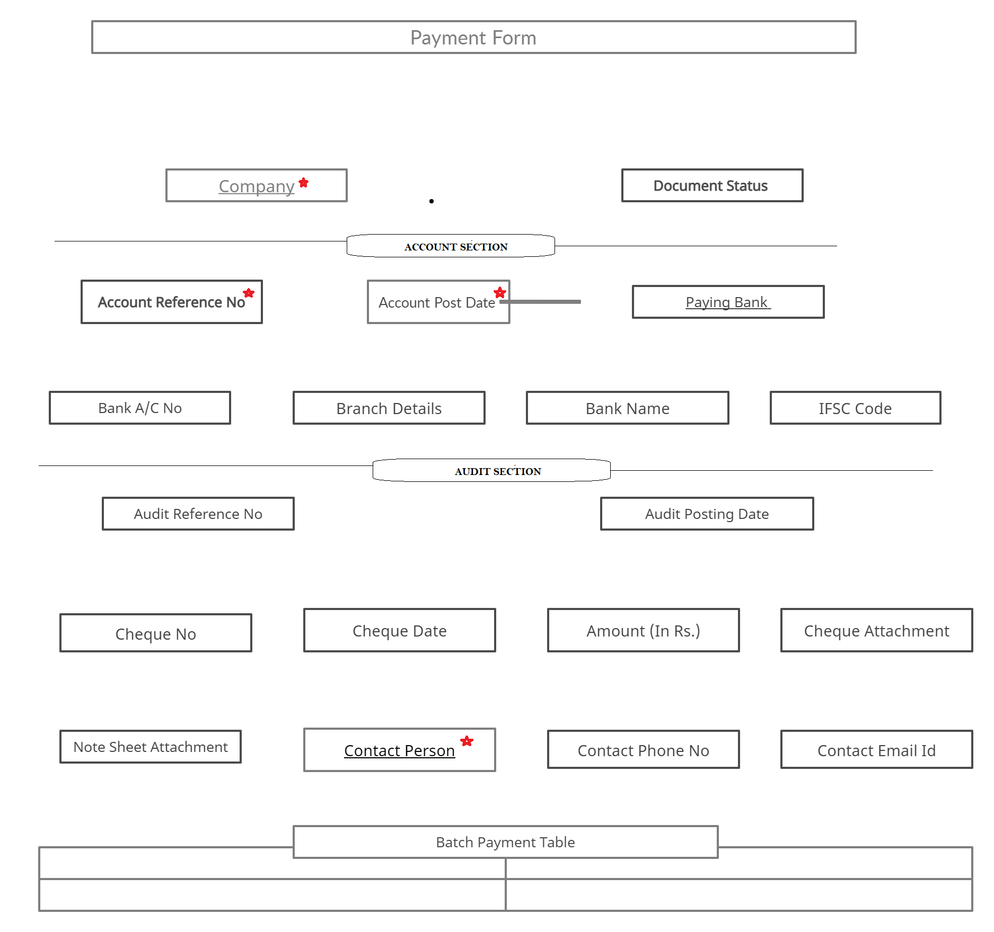

Get Invoices
- After data entry, Accounts User shall click to get all the invoices that are Unpaid
- Accounts user shall be shown a pop up with search filter criteria as shown below

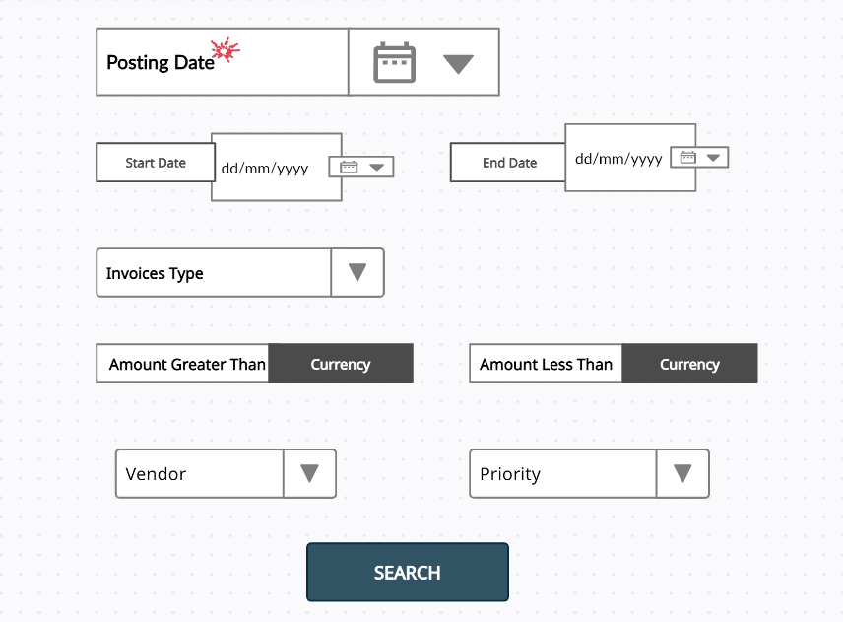

- Search Field Validation

- End Date shall be greater than Start Date
- Invoices Type shall be single selection
- On no selection of Invoices Type, all invoices shall be shown
- Amount Greater Than shall not be 0
- Amount Less Than shall be more than Amount Greater Than
- Vendor and Priority shall be single selection
- On no selection of Vendor or Priority, records shall be shown for all vendors and priority

- On click of Search, all the invoices fulfilling the search criteria shall be shown to the Accounts User in a child table with SAVE button (as shown below) :

CHILD TABLE
Invoice tracking number | Document Date | Vendor Code | Vendor Name | IFSC Code | A/C No. | Amount | SAP document number | Mode of Payment | UTR Number

- Workflow Stages :

Sl No | User Role | Action | Next State | Vendor Payment Form Status
1 | Accounts Clerk | Save | Accounts Clerk | Draft
2 | Accounts Clerk | Cancel |  | Cancelled
3 | Accounts Clerk | Submit | CFO, KIMS | Verified and Submitted Accounts User
4 | CFO, KIMS | Approve | Audit User | Approved by CFO,KIMS
5 | Audit User | Enter Data and Approve | Accounts Clerk | Payment Sheet Received by Audit
 | Auditor | Verify and Approve | Accounts Clerk | Approved By Auditor (Audit Verification)
6 | Accounts Clerk | Cheque issue,  Sign  Approve | Accounts Clerk | Cheque Preparation and Signature
7 | Accounts Clerk | - Verify,  - Send the cheque to Bank  - Approve | Accounts Clerk | Payment Sheet Submitted
8 | Accounts Clerk | SAP Transaction entry | Accounts Clerk | SAP Ledger Update
9 | EXTERNAL SYSTEM  UTR entry to SAP  Corresponding SAP Transaction fetched from SAP
10 | Accounts Clerk | - Print of “Vendor Payment Form”  - UTR Entry | Accounts Clerk | UTR Update
11 | Accounts Clerk | - cheque details entry,  - cheque attachment |  | Payment Done

- The corresponding note sheet status (note sheet screen) shall be changed from “Passed for Payment” to “Paid”

- Accounts Clerk shall be allowed to Cancel the batch payment note sheet after Saving and before Submitting the form

Authorized Signature Table
- PO T-Kitchen

- note sheet creator - Asst. Store keeper
- Dy. Head , MM
- GM, MM
- Accounts Clerk
- CFO
- Director Administration
- Audit User1
- Pro-VC
- Audit User2
- Accounts Clerk (final )

- PO - Consignment

- note sheet creator - consignment store keeper
- Dy. Head , MM
- GM, MM
- Accounts Clerk
- CFO
- Director Administration
- Audit User1
- Pro-VC
- Audit User2
- Accounts Clerk (final )

- PO - Material Management

- note sheet creator - Store Officer
- GM, MM
- Accounts Clerk
- CFO
- Director Administration
- Audit User1
- Pro-VC
- Audit User2
- Accounts Clerk (final )

- PO - Pharmacy

- note sheet creator
- GM, Pharmacy
- Accounts Clerk
- CFO
- Director Administration
- Audit User1
- Pro-VC
- Audit User2
- Accounts Clerk (final )

- NON-PO Contract

- Accounts Clerk (note keeper)
- CFO
- Director Administration
- Audit User1
- Pro-VC
- Audit User2
- Accounts Clerk (final)

- NON-PO Non Contract

- Accounts Clerk (note keeper)
- CFO
- Director Administration
- Medical Superintendent
- Audit User1
- Audit User2
- Accounts Clerk (final)

- Patient Refund

- Manager Lobby (note keeper)
- Director OPS
- Medical Superintendent
- Accounts Clerk
- CFO,KIMS
- Accounts Clerk (final step before Batch Payment)

- Payment Workflow

- Accounts Clerk
- CFO
- Audit User
- Auditor
- Accounts User / Clerk

Print Format / PDF
- System shall allow the user to print the note sheet only in pdf format
- User shall be able to view or take the print of the note sheet by click of  button in the detail view of a note sheet

- At each level in the workflow (user verification process), system shall allow the user(s) to preview the note sheet and supporting documents in PDF format by click of button
Download Attachment

- Only the latest signature shall be appended in the print format. For e.g.

- Note sheet creator submitted the note sheet
- GM, MM approved the note sheet
- Accounts clerk approved the note sheet
- Audit returned and transferred to GM, MM
- Again the note sheet went to GM, MM for verification and approval
- On approval by GM, MM, note sheet was again approved by Accounts Clerk
- On approval by Accounts clerk, it went to Audit for approval
….………………………..

Post final stage, in the print preview , GM,MM , Accounts Clerk and Audit latest signatures (steps 5,6,7) shall be fetched

Documents For Attachment
- PO / NON PO Invoice Types :

Document Type | Mandatory (Y/N)
Requisition form or Indent
Vendor Quotation
Comparative Statement
Approval Sheet
PO | Y
Delivery Challan
Invoice | Y
GRN
Bill Summary
Credit Memo
DO
Others

- PATIENT REFUND

Document Type | Mandatory (Y/N)
Patient Cancellation / Refund application Form | Y
Self declaration form | N
Refund sheet | Y
Final Bill | N
Refund Receipt | Y
Insurance Document | Y
Self identification document which should have photo (like Aadhar, Pan card,etc) | Y

Note :

- Attachment fields shall be check boxes for user selection
- On selection of a check box, system shall mandate the document attachment by the user
- Validation of Documents attachment - System shall allow the user to upload pdf file only

Email

21.1 Vendor / Supplier
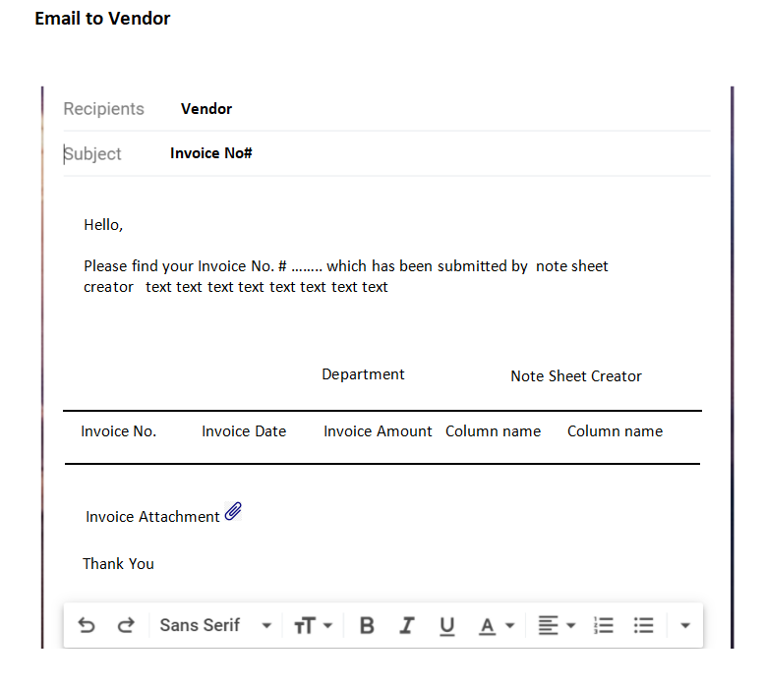
Invoice submission
Payment initiated

E-mail shall be triggered to the Vendor on following cases :

- Passed for Note Sheet status of invoice form by note sheet keeper
- Passed for payment approval by Accounts Clerk
- After the payment is done
- E-mail shall have Invoice attachment

21.2 Note Sheet Creator / Other Users
- At each level of user Approval, email shall be triggered to successor user. Below shall be the template :

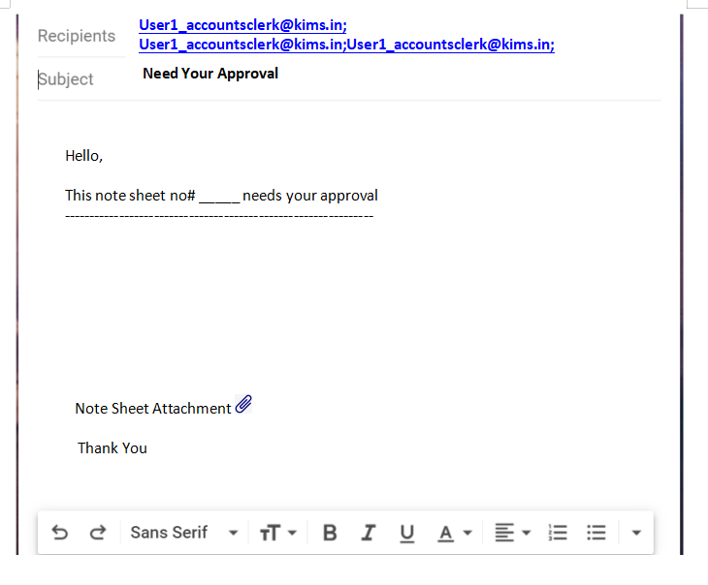

- If a note sheet is rejected and transferred by Level 5 to Level 2 then, email shall be triggered to Level 2, Level 3 and Level 4 users

- All users in the workflow shall receive email if payment is not cleared 10 days prior the threshold date

21.3 Third Party Department
- Email shall be triggered to third party department when the note sheet is forwarded for their verification and approval
- On approval by third party, email shall be triggered to the user who had initiated the forward

21.4 Email Attachment
Email shall have Invoice attachment for users to refer

21.5 Email for Amount Clearance Period in Days
Email shall be triggered to all the users when a note sheet is pending for approval since more than a pre defined days

Dashboard
- Dashboard will highlight the following details on a monthly basis. For e.g.

- No. Of Invoices Received
- No. Of Invoices In Process
- No. Of Invoices Pending
- No. Of Invoices Closed

- Invoice details in the Dashboard shall be Department wise. For e.g. User belonging to a Bio Medical department shall be able to see his / her department details
- Higher signing authority (or Super admin) shall be able to see all the details

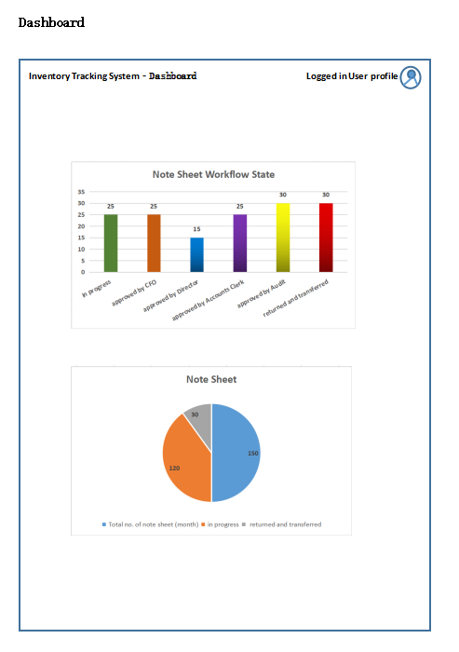
Figure : Dashboard UI

System Settings

23.1 Financial Criteria
A system configuration shall be maintained to define the “financial criteria” for execution of workflow. For e.g.

If note sheet amount is greater > 50,000 and < 100000 then Dy. Head , MM approval or reject and transfer shall be skipped from the workflow

Dynamic User Workflow
At any given of time, Administrator of the system shall be allowed to introduce (Add, Edit or Delete) a new stage in the workflow

Example :

- Administrator shall select T-Kitchen Invoice type to see the existing workflow : Form - PO T-Kitchen (Consumable)

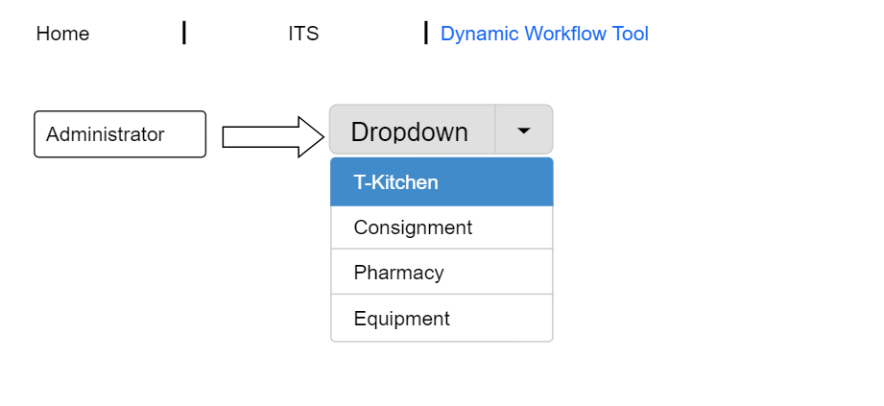

- The Existing workflow under T-Kitchen is as shown below :

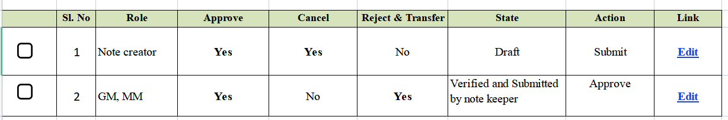

- Note creator shall fill in the note sheet and submit
- System shall save the note sheet and trigger the next user level (GM, MM) action
- GM, MM shall have the authority to approve or reject andd transfer
- Based on the action performed by GM, MM, the workflow shall either navigate to first user (note creator) or end the workflow

- Administrator shall add a new state for the role Clerk (as shown below)

Add Row

- Administrator shall click Add Row button

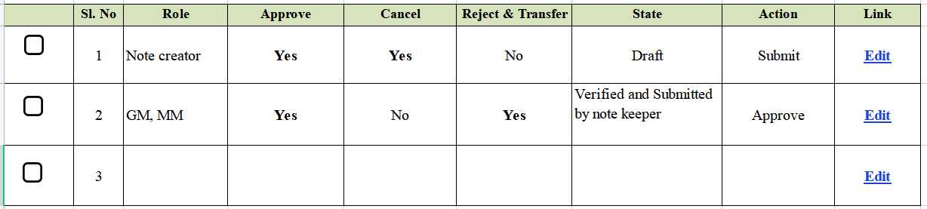

- The New workflow under T-Kitchen is as shown below :

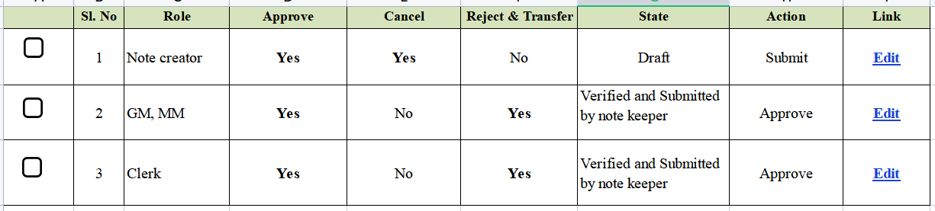

- Administrator shall drag the new state to Row 2 (as shown below)

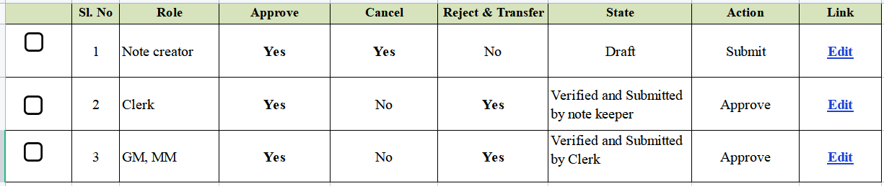

- Administrator shall click “Edit” to modify the State of GM, MM

New State

- Note sheet creator shall fill in the note sheet and submit
- System shall save the note sheet and trigger the next user level (Clerk) action
- Clerk shall have the authority to approve or reject and transfer
- Based on the action performed by Clerk, the workflow shall either navigate to first user (note sheet creator) or next user i.e. GM,MM
- GM, MM shall have the authority to approve or reject and transfer
- Based on the action performed by GM, MM, the workflow shall either navigate to first user (note sheet creator) or end of the workflow

- Administrator shall also be able to Delete a state in the workflow by selecting a particular row

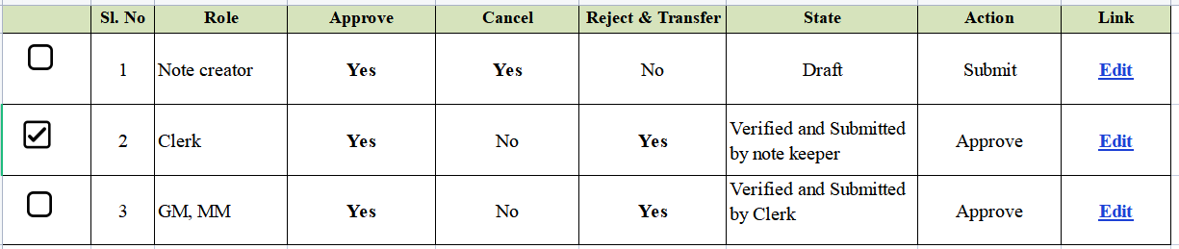
Delete

Role Permission Tool
- This screen shall be accessible by System Administrator
- The System Administrator shall give access rights to users for Invoice Type screens

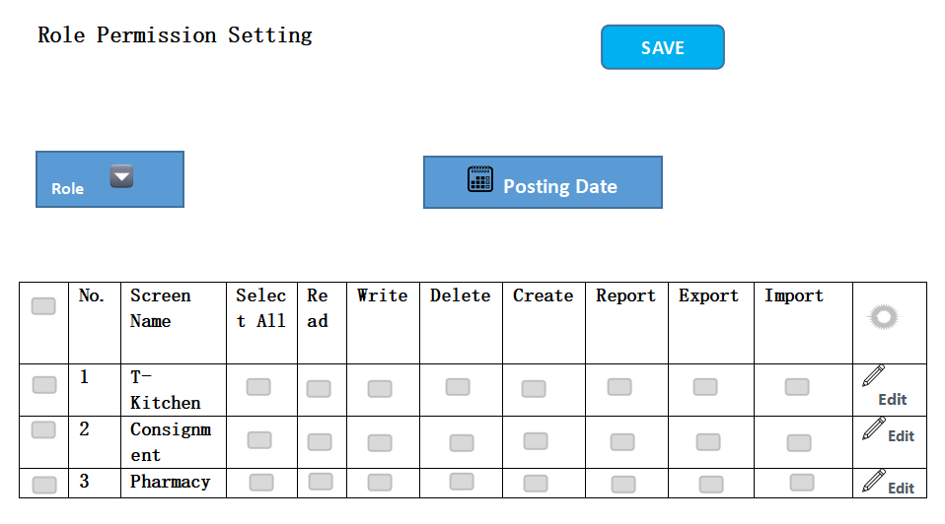

User Permission Tool

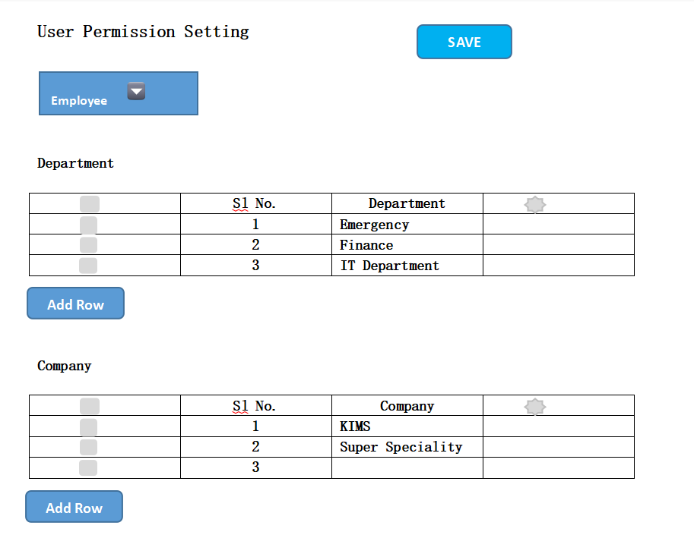

Absent Employee Replacement Tool
- This tool shall be accessible to System Administrator.
- System Administrator shall grant the verification and approval authority to an Employee when the signing authority (for e.g. CFO, KIMS, PRO VC, Director, Administration, etc) shall be on leave or not available.

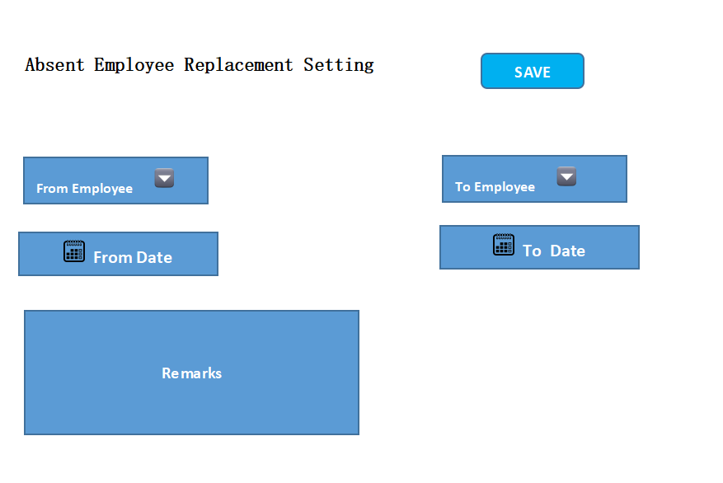

Report
- System Administrator shall be allowed to grant the access to view / edit the reports.
- Reports shall be available for all invoice types. User shall be allowed to define the search criteria for view of Reports.

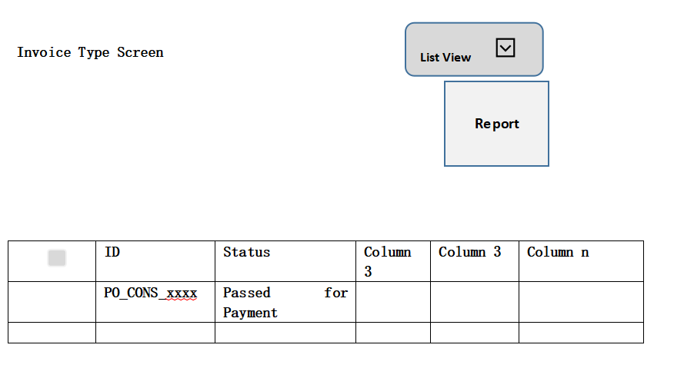

- User shall be allowed to export the report to .xls file

